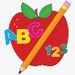Primary 2 Homework
Week Beginning: 22nd September 2026
Here is a guide to help you for this week. You can choose how to organise your tasks to suit what works for you.
Please bring book bags to school every day. They will be collected in on a Friday as there will not be any homework at the weekend. If you feel you want to continue with some of the homework over the weekend, please just let me know. *Your child can use their homework jotter for any writing they do. Spelling words (these will be tested on a Friday along with the common words).
 | Literacy | Numeracy
 | Joined Phonemes  This week we are learning about ow (eg. snow).  Spelling words (these will be tested on a Friday along with the common words).  low grow throw follow shallow show  Get your child to make up the rainbow alphabet. Use the letters with the new joined phoneme to make ow words.  Write each of your spelling words three times. Use a pencil first, then a coloured pencil and lastly a pen.  *Challenge: Your child can write sentences with their words if they wish.   | Addition to 20  Click the game below. Choose Doubles (Doubles to 10).  https://www.topmarks.co.uk/maths-games/hit-the-button  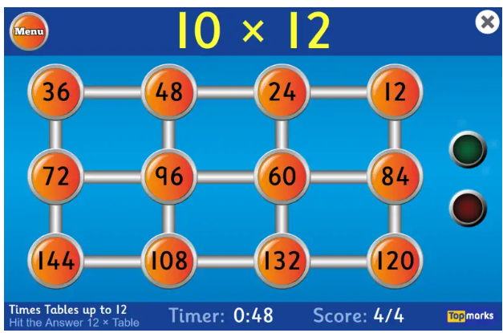
Common Words
The new common words for this week are
yellow grow again food
Look for your common words in books, magazines, posters, etc. Note down how many times you see them.
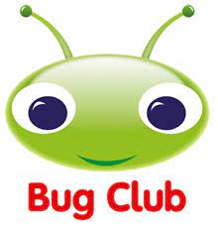

Your child will get their books home in their book bag when they have completed them in class.
Remember to have lots of fun! 

