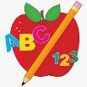 Primary 2 Homework

Your child has a jotter in their book bag. This can be used for any written homework your child does.
In your child’s book bag is a rainbow alphabet board with letters and letter lids. They have Stage 1 joined phoneme letter lids and Stage 2 joined phonemes will be added to them as they learn them. They can use the letters and joined phonemes to practise blending them together to make words to read and write.


Your child also has a booklet of all the Stage 1 common words taught in Primary 1 in their book bag. They can use it to practise reading the words and spelling the words. If your child can read and spell a word they can colour in that brick. Stage 2 word walls will be added after each set has been taught in class.
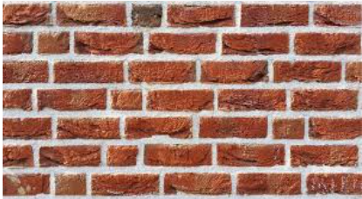

Homework will be posted on the Primary 1/2 blog weekly. Primary 2 will have different homework to Primary 1. Please also check your child’s book bag for any reading books.
*Your child should bring their book bag to school every day.

