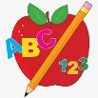 Primary 2 Homework
Week Beginning: 7th September 2026
Here is a guide to help you for this week. You can choose how to organise your tasks to suit what works for you.
Please bring book bags to school every day. They will be collected in on a Friday as there will not be any homework at the weekend. If you feel you want to continue with some of the homework over the weekend, please just let me know. *Your child can use their homework jotter for any writing they do.
 | Literacy | Numeracy
 | Joined Phonemes  Your child has been revising Stage 1 Joined Phonemes.  Your child is now ready to start learning new P2 joined phonemes.  This week we are learning about ay.  Spelling words (these will be tested on a Friday along with the common words).  day tray play stay prayer way clay  Get your child to make up the rainbow alphabet. Use the letters with the new joined phoneme letter lid to make the words above.  They can write the words in their jotter. Can they think of anymore?  Can you find any ay words in the environment and/or around the house?    *Challenge: Your child can write sentences with their words if they wish.   | Addition to 20  We have been revising addition to 10 and the different strategies used - add 0, add 1, add 2, turnarounds and doubles.  We are now beginning addition to 20. The same strategies apply.  New strategy +10.  Click on the game below for your child to play a game where they need to use their strategies mentally.  https://www.arcademics.com/games/alien    *There is also a number line in your child’s book bag should they need some assistance.
Common Words

Your child has been revising Stage 1 common words.
Your child is now ready to learn Stage 2 common words.

The new common words for this week are
day away always today

*These words fit in with your spelling activity as they use the new joined phoneme.
Reading

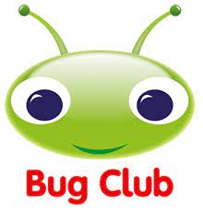
Your child will get their books home in their book bag when they have completed them in class.
Remember to have lots of fun! 

