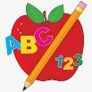Primary 2 Homework
Week Beginning: 8th June 2026
Here is a guide to help you for this week. You can choose how to organise your tasks to suit what works for you.
Please bring book bags to school every day. They will be collected in on a Friday as there will not be any homework at the weekend. If you feel you want to continue with some of the homework over the weekend, please just let me know. *Your child can use their homework jotter for any writing they do.
 | Literacy | Numeracy
 | Grammar  In class we were looking at common nouns, adjectives and verbs when we did our book study. Make a list of your own common nouns, adjectives and verbs.  green  run  plant | Multiplication  Click on the game below. Choose X then pick a times table to practise.  https://www.topmarks.co.uk/maths-games/mental-maths-train  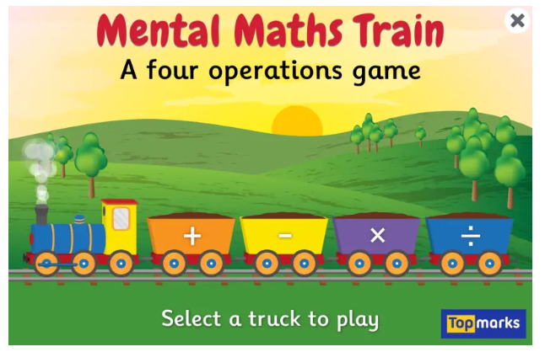
Common Words

We are finished Stage 2 common words. Please continue to practise reading and spelling them, especially if any are still proving tricky.

Group 1 words - day away always today each ask year eat yellow grow again food

Group 2 words (so far) – blue best number other very took fast there their then some last

Group 3 words – because week keep when what soon many book how where now too round found wish men

Group 4 words – who right hand after fly Mr. two bring five time life line more home school Mrs.

Group 5 words – take gave cold don’t every find want girl father mother head jump

Group 6 words – four miss never these will well fell call three room long tree

Group 7 words - under were thing know
green people which another
Joined Phonemes

We are finished the joined phonemes for Stage 2. Please continue to practise identifying them and spelling with them in your jotter, especially if any are still tricky.

The phonemes your child should know are –
Group 1 – ay, ea (as in leaf), ow (as in snow)
Group 2 – ue (as in oo and yoo sounds), aw, oi
Group 3 – au, ew, ow (as in owl), ou
Group 4 – igh, y (as in fly), i_e (as in hide), o_e (as in home)
Group 5 – a_e (cake), u_e (cube), e_e (here)
Group 6 -ss, ll, ff
Group 7 – kn, mb



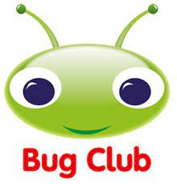
Your child will get their books home in their book bag when they have completed them in class.

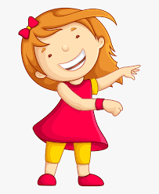Remember to have lots of fun! 