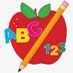Primary 2 Homework
Week Beginning: 25th May 2026
Here is a guide to help you for this week. You can choose how to organise your tasks to suit what works for you.
Please bring book bags to school every day. They will be collected in on a Friday as there will not be any homework at the weekend. If you feel you want to continue with some of the homework over the weekend, please just let me know. *Your child can use their homework jotter for any writing they do.
 | Literacy | Numeracy
 | Joined Phonemes  This week we are consolidating – ll, ff, ss, kn, mb.  Make and write as many words as you can.  Write a funny story including at least one word for each joined phoneme we are practising.  The phonemes your child should know are –  Group 1 – ay, ea (as in leaf), ow (as in snow)  Group 2 – ue (as in oo and yoo sounds), aw, oi  Group 3 – au, ew, ow (as in owl), ou  Group 4 – igh, y (as in fly), i_e (as in hide), o_e (as in home)  Group 5 – a_e (cake), u_e (cube), e_e (here)  Group 6 -ss, ll, ff  Group 7 – kn, mb   | Multiplication  Click on the games below to explore equal groups.  https://wordwall.net/resource/10714623/equal-groups  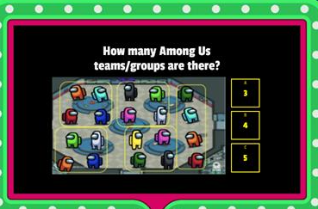  https://wordwall.net/resource/7720198/math/multiplication-equal-sized-groups  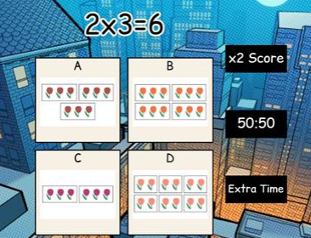
Common Words

We are consolidating Group 7 words.

Can your write each word in a fancy way?
(Bubble writing, wiggly letters, using straight lines only, etc).

Group 1 words - day away always today each ask year eat yellow grow again food

Group 2 words (so far) – blue best number other very took fast there their then some last

Group 3 words – because week keep when what soon many book how where now too round found wish men

Group 4 words – who right hand after fly Mr. two bring five time life line more home school Mrs.

Group 5 words – take gave cold don’t every find want girl father mother head jump

Group 6 words – four miss never these will well fell call three room long tree

Group 7 words - under were thing know
green people which another

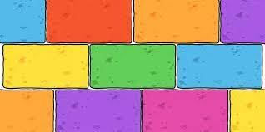
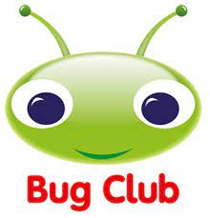
Your child will get their books home in their book bag when they have completed them in class.

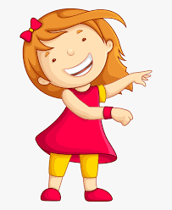Remember to have lots of fun! 

