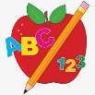Primary 2 Homework
Week Beginning: 4th May 2026
Here is a guide to help you for this week. You can choose how to organise your tasks to suit what works for you.
Please bring book bags to school every day. They will be collected in on a Friday as there will not be any homework at the weekend. If you feel you want to continue with some of the homework over the weekend, please just let me know. *Your child can use their homework jotter for any writing they do.
This homework is for two weeks - to be completed by Friday 15th May 2026.
 | Literacy | Numeracy
 | Joined Phonemes  New joined phonemes – kn mb  Spelling lists  kn - knock know knee knight kneel knew  mb - comb lamb climb crumb thumb  Write these words in lowercase and uppercase letters. knock KNOCK  comb COMB  Which spelling words are common nouns? Can you make the common noun a plural?  comb combs  *Choose some words to write sentences with.  The phonemes your child should know are –  Group 1 – ay, ea (as in leaf), ow (as in snow)  Group 2 – ue (as in oo and you sounds), aw, oi  Group 3 – au, ew, ow (as in owl), ou  Group 4 – igh, y (as in fly), i_e (as in hide), o_e (as in home)  Group 5 – a_e (cake), u_e (cube), e_e (here)  Group 6 -ss, ll, ff   | Subtraction to 20  We are exploring strategies for subtracting from numbers up to 20. The children can use the strategies to work out the calculations.  https://www.topmarks.co.uk/maths-games/subtraction-grids  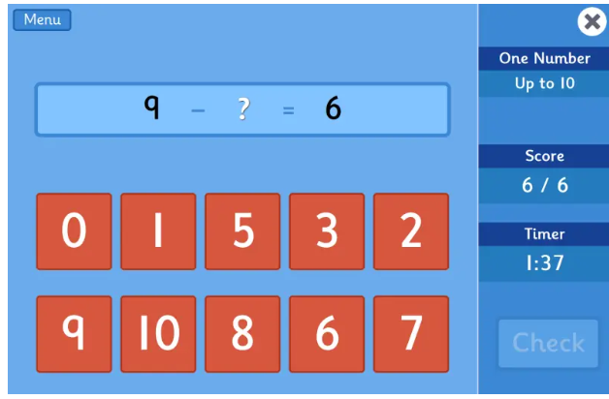
Common Words

Group 7 Common Words -

under were thing know
green people which another

Can you make up a silly story with the common words? Be creative!

Group 1 words - day away always today each ask year eat yellow grow again food

Group 2 words (so far) – blue best number other very took fast there their then some last

Group 3 words – because week keep when what soon many book how where now too round found wish men

Group 4 words – who right hand after fly Mr. two bring five time life line more home school Mrs.

Group 5 words – take gave cold don’t every find want girl father mother head jump

Group 6 words – four miss never these will well fell call three room long tree

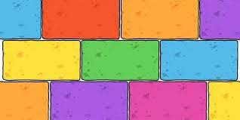
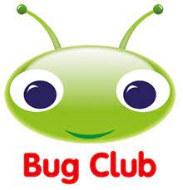
Your child will get their books home in their book bag when they have completed them in class.

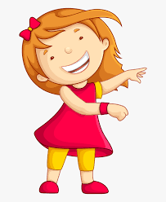Remember to have lots of fun! 