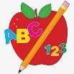Primary 2 Homework
Week Beginning: 27th April 2026
Here is a guide to help you for this week. You can choose how to organise your tasks to suit what works for you.
Please bring book bags to school every day. They will be collected in on a Friday as there will not be any homework at the weekend. If you feel you want to continue with some of the homework over the weekend, please just let me know. *Your child can use their homework jotter for any writing they do.
 | Literacy | Numeracy
 | Joined Phonemes  This week is a consolidation week for ss, ll, ff.  Make up your own spelling list for each joined phoneme. Whoever is helping you with your homework, ask them to make the lists as well and see who has the most!  *Choose some words to write sentences with.  The phonemes your child should know are –  Group 1 – ay, ea (as in leaf), ow (as in snow)  Group 2 – ue (as in oo and you sounds), aw, oi  Group 3 – au, ew, ow (as in owl), ou  Group 4 – igh, y (as in fly), i_e (as in hide), o_e (as in home)  Group 5 – a_e (cake), u_e (cube), e_e (here)  Group 6 -ss, ll, ff   | Subtraction to 20  We are exploring strategies for subtracting from numbers up to 20. The children can use the strategies to work out the calculations or use the number line.  https://www.topmarks.co.uk/maths-games/robot-more-or-less  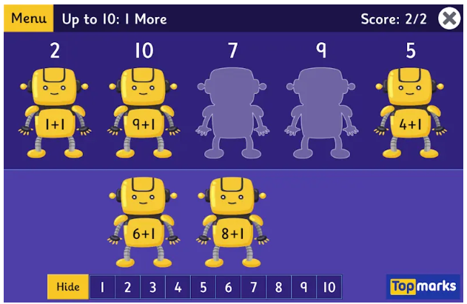
Common Words

This is a consolidation week for Group 6 common words.

Your child has the Group 6 word wall in their book bag.
Practise reading and spelling each word. When they can do both for each word colour in the brick.

Group 1 words - day away always today each ask year eat yellow grow again food

Group 2 words (so far) – blue best number other very took fast there their then some last

Group 3 words – because week keep when what soon many book how where now too round found wish men

Group 4 words – who right hand after fly Mr. two bring five time life line more home school Mrs.

Group 5 words – take gave cold don’t every find want girl father mother head jump

Group 6 words – four miss never these will well fell call three room long tree

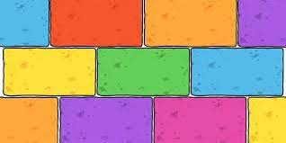
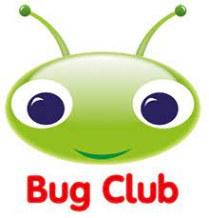
Your child will get their books home in their book bag when they have completed them in class.

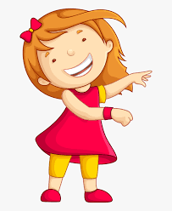Remember to have lots of fun! 