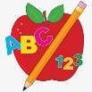Primary 2 Homework
Week Beginning: 2oth April 2026
Here is a guide to help you for this week. You can choose how to organise your tasks to suit what works for you.
Please bring book bags to school every day. They will be collected in on a Friday as there will not be any homework at the weekend. If you feel you want to continue with some of the homework over the weekend, please just let me know. *Your child can use their homework jotter for any writing they do.
 | Literacy | Numeracy
 | Joined Phonemes  This week’s phoneme is ff (off).  Remember this joined phoneme does not appear at the start of a word.  This week’s spelling words are –  off cliff cuff stiff stuff different  How many more words can you think of? Make a list. Highlight the joined phoneme in each word – off stuff.  *Choose some words to write sentences with.  The phonemes your child should know are –  Group 1 – ay, ea (as in leaf), ow (as in snow)  Group 2 – ue (as in oo and you sounds), aw, oi  Group 3 – au, ew, ow (as in owl), ou  Group 4 – igh, y (as in fly), i_e (as in hide), o_e (as in home)  Group 5 – a_e (cake), u_e (cube), e_e (here)  Group 6 -ss, ll   | Subtraction to 20  We are revising subtraction within 10 before looking at subtraction within 20. Click on the link below to play Fact Families. This shows the link between addition and subtraction.  https://www.topmarks.co.uk/number-facts/number-fact-families  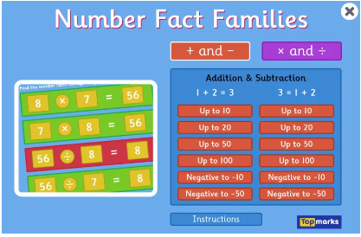
Common Words

This week’s common words are –

three room long tree

Write a sentence for each word. For an extra challenge, try to include a proper noun or common noun into your sentence.

Group 1 words - day away always today each ask year eat yellow grow again food

Group 2 words (so far) – blue best number other very took fast there their then some last

Group 3 words – because week keep when what soon many book how where now too round found wish men

Group 4 words – who right hand after fly Mr. two bring five time life line more home school Mrs.

Group 5 words – take gave cold don’t every find want girl father mother head jump

Group 6 words – four miss never these will well fell call

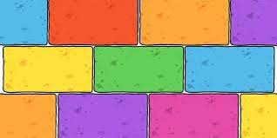
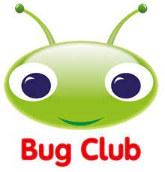
Your child will get their books home in their book bag when they have completed them in class.

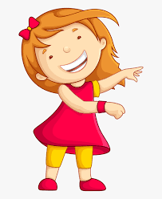Remember to have lots of fun! 