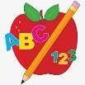Primary 2 Homework
Week Beginning: 30th March 2026

There is no homework this week but please continue to practise any phonemes/common words that are still proving tricky.
Your child will still be given reading books up until Wednesday.
The book bags will be collected in on Thursday.



Enjoy the holidays!

