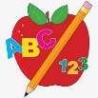Primary 2 Homework
Week Beginning: 23rd March 2026
Here is a guide to help you for this week. You can choose how to organise your tasks to suit what works for you.
Please bring book bags to school every day. They will be collected in on a Friday as there will not be any homework at the weekend. If you feel you want to continue with some of the homework over the weekend, please just let me know. *Your child can use their homework jotter for any writing they do.
 | Literacy | Numeracy
 | Joined Phonemes  This week’s phoneme is ll (eg. will).  Remember this joined phoneme does not appear at the start of a word.  This week’s spelling words are –  well spill fill dull drill allow shallow  Write your words across and down, eg.  w e l l  e  l  l  *Challenge – Can you join all of your words together like a crossword puzzle?  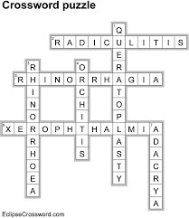  *Choose some words to write sentences with.  The phonemes your child should know are –  Group 1 – ay, ea (as in leaf), ow (as in snow)  Group 2 – ue (as in oo and you sounds), aw, oi  Group 3 – au, ew, ow (as in owl), ou  Group 4 – igh, y (as in fly), i_e (as in hide), o_e (as in home)  Group 5 – a_e (cake), u_e (cube), e_e (here)  Group 6 -ss   | Addition to 20  Click the game below. Choose Doubles or Number Bonds. Try to beat your score each time.  https://www.topmarks.co.uk/maths-games/hit-the-button  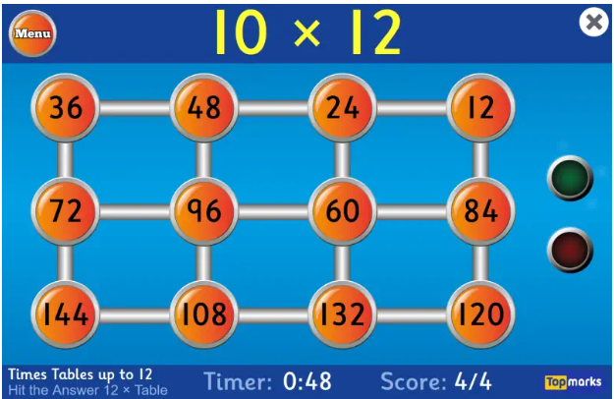
Common Words

This week’s common words are –

well will fell call

Use these words with the spelling task as they also use the new joined phoneme.

Group 1 words - day away always today each ask year eat yellow grow again food

Group 2 words (so far) – blue best number other very took fast there their then some last

Group 3 words – because week keep when what soon many book how where now too round found wish men

Group 4 words – who right hand after fly Mr. two bring five time life line more home school Mrs.

Group 5 words – take gave cold don’t every find want girl father mother head jump

Group 6 words – four miss never these

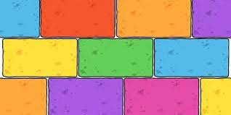
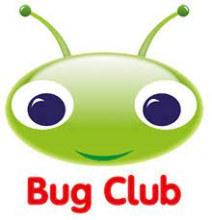
Your child will get their books home in their book bag when they have completed them in class.

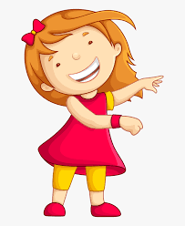Remember to have lots of fun! 

