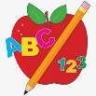Primary 2 Homework
Week Beginning: 16th March 2026
Here is a guide to help you for this week. You can choose how to organise your tasks to suit what works for you.
Please bring book bags to school every day. They will be collected in on a Friday as there will not be any homework at the weekend. If you feel you want to continue with some of the homework over the weekend, please just let me know. *Your child can use their homework jotter for any writing they do.
 | Literacy | Numeracy
 | Joined Phonemes  This week’s phoneme is ss (eg. dress).  This week’s spelling words are –  mess class less dress kiss grass lesson  Write your words the way we make them on the rainbows in class. Blue for a consonant, red for a vowel, green for the joined phoneme. Eg. dress  *Choose some words to write sentences with.  The phonemes your child should know are –  Group 1 – ay, ea (as in leaf), ow (as in snow)  Group 2 – ue (as in oo and you sounds), aw, oi  Group 3 – au, ew, ow (as in owl), ou  Group 4 – igh, y (as in fly), i_e (as in hide), o_e (as in home)  Group 5 – a_e (cake), u_e (cube), e_e (here)   | Addition to 20  Click the game below. Choose ‘Count on and back’.  https://www.topmarks.co.uk/learning-to-count/blast-off  
Common Words

This week’s common words are –

four miss never these

Type your words up in different fonts or write them in different styles. Eg. four four four four

Group 1 words - day away always today each ask year eat yellow grow again food

Group 2 words (so far) – blue best number other very took fast there their then some last

Group 3 words – because week keep when what soon many book how where now too round found wish men

Group 4 words – who right hand after fly Mr. two bring five time life line more home school Mrs.

Group 5 words – take gave cold don’t every find want girl father mother head jump


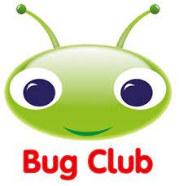
Your child will get their books home in their book bag when they have completed them in class.

This Thursday is World Book Day. Your child has a Reading Bingo game in their book bag that they can use throughout the week.

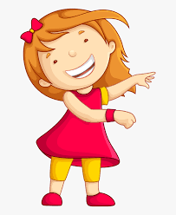Remember to have lots of fun! 

