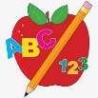Primary 2 Homework
Week Beginning: 9th March 2026
Here is a guide to help you for this week. You can choose how to organise your tasks to suit what works for you.
Please bring book bags to school every day. They will be collected in on a Friday as there will not be any homework at the weekend. If you feel you want to continue with some of the homework over the weekend, please just let me know. *Your child can use their homework jotter for any writing they do.
 | Literacy | Numeracy
 | Joined/Split Phonemes  This is a consolidation week for magic e words.  Click on the link below for the job of magic e.  https://www.youtube.com/watch?v=c3oA4wfUBak  Can you find any magic e words in magazines or newspapers? Copy them down in your jotter or cut them out to stick in your jotter. With permission!  The phonemes your child should know are –  Group 1 – ay, ea (as in leaf), ow (as in snow)  Group 2 – ue (as in oo and you sounds), aw, oi  Group 3 – au, ew, ow (as in owl), ou  Group 4 – igh, y (as in fly), i_e (as in hide), o_e (as in home)  Group 5 – a_e (cake), u_e (cube), e_e (these)   | Addition to 20  Click the game below. Choose the addition train.  https://www.topmarks.co.uk/maths-games/mental-maths-train  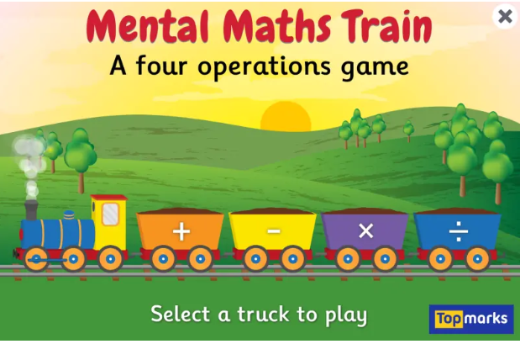  Challenge  Try making up 3 digit calculations for numbers up to 20.  (eg. 2+ 5 + 7 = 14)
Common Words

This is a consolidation week for Group 5 words.

Your child has the Group 5 word wall in their book bag.
Practise reading and spelling each word. When they can do both for each word colour in the brick.

Group 1 words - day away always today each ask year eat yellow grow again food

Group 2 words (so far) – blue best number other very took fast there their then some last

Group 3 words – because week keep when what soon many book how where now too round found wish men

Group 4 words – who right hand after fly Mr. two bring five time life line more home school Mrs.

Group 5 words – take gave cold don’t every find want girl father head mother jump


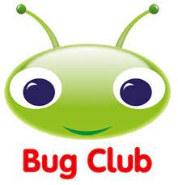
Your child will get their books home in their book bag when they have completed them in class.

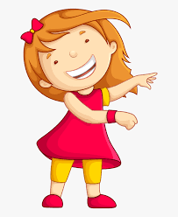Remember to have lots of fun! 

