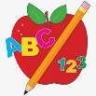Primary 2 Homework
Week Beginning: 2nd March 2026
Here is a guide to help you for this week. You can choose how to organise your tasks to suit what works for you.
Please bring book bags to school every day. They will be collected in on a Friday as there will not be any homework at the weekend. If you feel you want to continue with some of the homework over the weekend, please just let me know. *Your child can use their homework jotter for any writing they do.
 | Literacy | Numeracy
 | Joined/Split Phonemes  This week’s phoneme is e-e (eg. here).  Click on the link below to find out about the job of ‘Magic e’ for e-e.  https://www.youtube.com/watch?v=Ts8Jsq7a9qQ  This week’s spelling words are –  these here eve complete even  Highlight the split phoneme in green. Can you add any more words?  these  *Choose some words to write sentences with.  The phonemes your child should know are –  Group 1 – ay, ea (as in leaf), ow (as in snow)  Group 2 – ue (as in oo and you sounds), aw, oi  Group 3 – au, ew, ow (as in owl), ou  Group 4 – igh, y (as in fly), i_e (as in hide), o_e (as in home)  Group 5 – a_e (cake), u_e (cube)   | Addition to 20  Click the game below. Choose Number Bonds and Doubles.  https://www.topmarks.co.uk/maths-games/hit-the-button  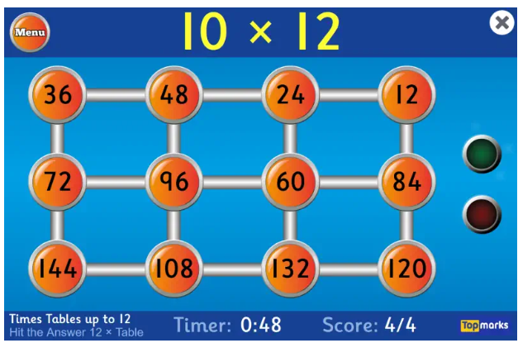  .
Common Words

This week’s common words are –

father mother head jump

Spell the words out loud using the letter names.

Write the words in lowercase letters and then in capitals (father FATHER).

Group 1 words - day away always today each ask year eat yellow grow again food

Group 2 words (so far) – blue best number other very took fast there their then some last

Group 3 words – because week keep when what soon many book how where now too round found wish men

Group 4 words – who right hand after fly Mr. two bring five time life line more home school Mrs.

Group 5 words – take gave cold don’t every find want girl

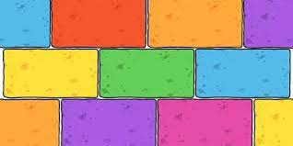
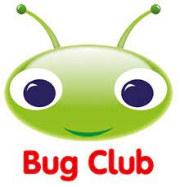
Your child will get their books home in their book bag when they have completed them in class.

This Thursday is World Book Day. Your child has a Reading Bingo game in their book bag that they can use throughout the week.

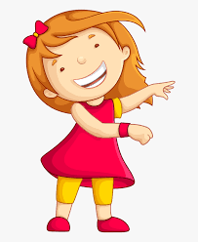Remember to have lots of fun! 

