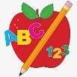Primary 2 Homework
Week Beginning: 23rd February 2026
Here is a guide to help you for this week. You can choose how to organise your tasks to suit what works for you.
Please bring book bags to school every day. They will be collected in on a Friday as there will not be any homework at the weekend. If you feel you want to continue with some of the homework over the weekend, please just let me know. *Your child can use their homework jotter for any writing they do.
 | Literacy | Numeracy
 | Joined/Split Phonemes  This week’s split phoneme is u-e (eg. rule).  Click on the link below to find out about the job of ‘Magic e’ for u-e.  https://www.youtube.com/watch?v=cl82zAHzkmM  This week’s spelling words are –  June rule ruler rude flute tune  Practise writing your spelling words. Diacritically mark the words like you have been doing in your workbooks. This helps to see how the words are made up (eg. joined phonemes, single phonemes, split phonemes).  Joined phonemes have a line, split phonemes have an arch, single phonemes have a dot.  shake  *Choose some of your words to make sentences with.  The phonemes your child should know are –  Group 1 – ay, ea (as in leaf), ow (as in snow)  Group 2 – ue (as in oo and you sounds), aw, oi  Group 3 – au, ew, ow (as in owl), ou  Group 4 – igh, y (as in fly), i_e (as in hide), o_e (as in home)  Group 5 – a_e (cake)   | Addition to 20  Click on the game below. Click Level 2.  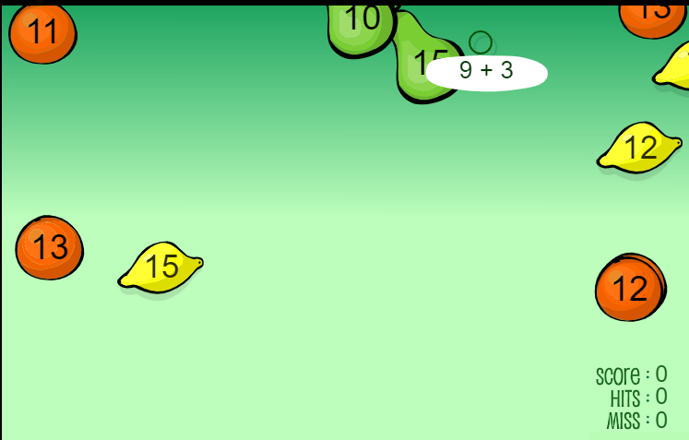  https://www.sheppardsoftware.com/math/addition/fruit-splat-game/  Use the different strategies we have been using to work out the calculations. If you need a number line, use your 100 square.
Common Words

This week’s common words are –

every find want girl

Spell the words out loud using the letter names.

Try writing these words in different styles eg. every every every every
You can write with black or different colours, paint or type it. You choose.

Group 1 words - day away always today each ask year eat yellow grow again food

Group 2 words (so far) – blue best number other very took fast there their then some last

Group 3 words – because week keep when what soon many book how where now too round found wish men

Group 4 words – who right hand after fly Mr. two bring five time life line more home school Mrs.

Group 5 words – take gave cold don’t

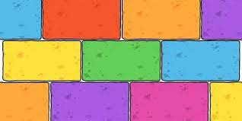
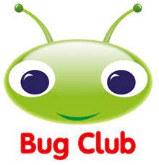
Your child will get their books home in their book bag when they have completed them in class.
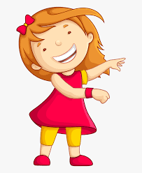Remember to have lots of fun! 

