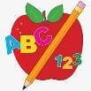Primary 2 Homework
Week Beginning: 16th February 2026
Here is a guide to help you for this week. You can choose how to organise your tasks to suit what works for you.
Please bring book bags to school every day. They will be collected in on a Friday as there will not be any homework at the weekend. If you feel you want to continue with some of the homework over the weekend, please just let me know. *Your child can use their homework jotter for any writing they do.
 | Literacy | Numeracy
 | Joined/Split Phonemes  This week’s split phoneme is a-e (eg. cake).  Click on the link below to find out about the job of ‘Magic e’ for a-e.  https://www.youtube.com/watch?v=HxoTZ_i2rcs  This week’s spelling words are –  cake bake came name game sale brake  Practise writing your spelling words. Diacritically mark the words like you have been doing in your workbooks. This helps to see how the words are made up (eg. joined phonemes, single phonemes, split phonemes).  Joined phonemes have a line, split phonemes have an arch, single phonemes have a dot.  shake  *Choose some of your words to make sentences with.  The joined phonemes your child should know are –  Group 1 – ay, ea (as in leaf), ow (as in snow)  Group 2 – ue (as in oo and you sounds), aw, oi  Group 3 – au, ew, ow (as in owl), ou  Group 4 – igh, y (as in fly), i_e (as in hide), o_e (as in home)   | Addition to 20  The children are exploring fact families for numbers up to 20.  Click on the game below. Remind them to use their strategies.  https://www.topmarks.co.uk/number-facts/number-fact-families  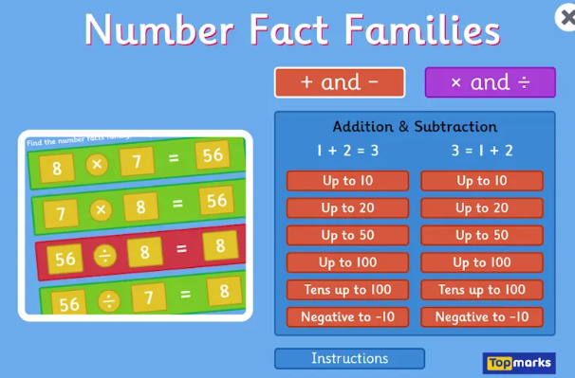
Common Words

The new common words for Group 5 are -
take gave cold don’t

Write your words using bubble writing.

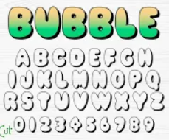

Group 1 words - day away always today each ask year eat yellow grow again food

Group 2 words (so far) – blue best number other very took fast there their then some last

Group 3 words – because week keep when what soon many book how where now too round found wish men

Group 4 words – who right hand after fly Mr. two bring five time life line more home school Mrs.

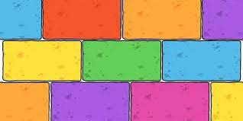
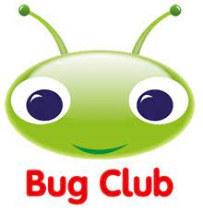
Your child will get their books home in their book bag when they have completed them in class.
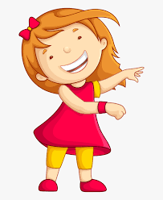Remember to have lots of fun! 