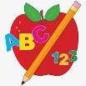Primary 2 Homework
Week Beginning: 2nd February 2026
Here is a guide to help you for this week. You can choose how to organise your tasks to suit what works for you.
Please bring book bags to school every day. They will be collected in on a Friday as there will not be any homework at the weekend. If you feel you want to continue with some of the homework over the weekend, please just let me know. *Your child can use their homework jotter for any writing they do.
 | Literacy | Numeracy
 | Joined/Split Phonemes  This week we are consolidating the joined/split phonemes taught for Group 4.  Look for words using these phonemes in books, magazines, in the environment, etc. Make a note of the ones you find in your jotter. Choose some of the words to make a sentence with. Remember to use capital letters, full stops, finger spaces, and read over it to make sure it makes sense.  The joined phonemes your child should know are –  Group 1 – ay, ea (as in leaf), ow (as in snow)  Group 2 – ue (as in oo and you sounds), aw, oi  Group 3 – au, ew, ow (as in owl), ou  Group 4 – igh, y (as in fly), i_e (as in hide), o_e (as in home)   | Addition to 20  Click below. Your child can use this to work out calculations that bridge 10.  (eg. 9+4, 6+8).  This is a strategy where both of the numbers that are being added together are less than ten but add up to a teen number.  https://www.didax.com/apps/ten-frame/  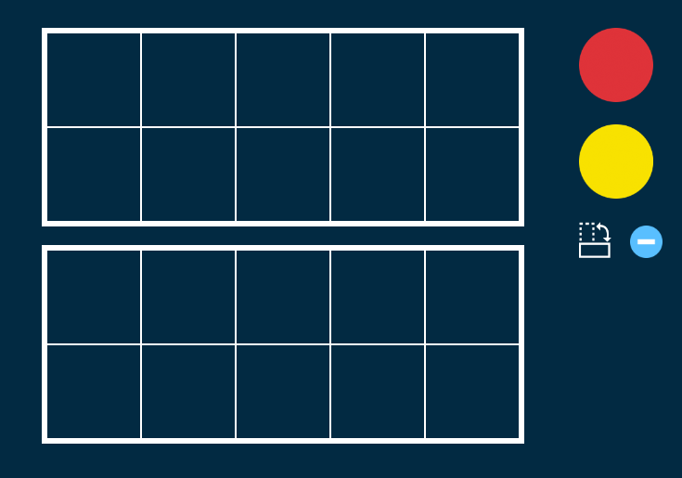    For each number in the addition calculation use a different colour counter – 9+4 (9-red,  4-yellow).  It is easier to make up the first ten frame with the counters and they can see what is left over to add to the 10 (a strategy already used).  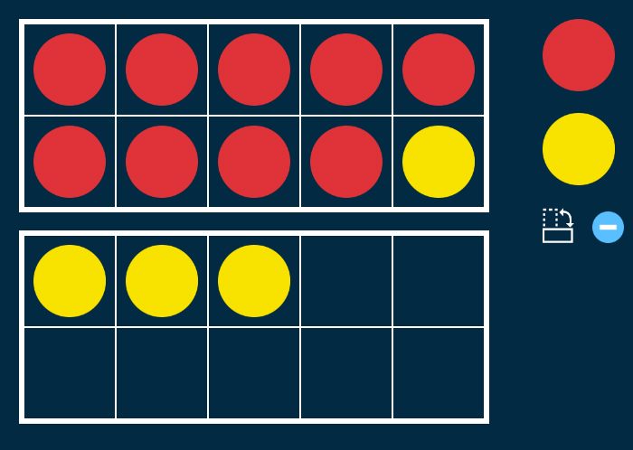  9+4 changes to 10+3 which equals 13  9+4=13  Your child can write the calculations down in their jotter.
Common Words

This week is for consolidation and assessment. Continue to practise the reading and spelling of all four groups of words. Focus more on the ones that your child may find tricky.

*Group 4 word wall is in your child’s book bag.

Group 1 words - day away always today each ask year eat yellow grow again food

Group 2 words (so far) – blue best number other very took fast there their then some last

Group 3 words – because week keep when what soon many book how where now too round found wish men

Group 4 words – who right hand after fly Mr. two bring five time life line more home school Mrs.

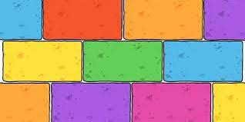
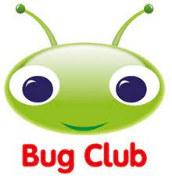
Your child will get their books home in their book bag when they have completed them in class.
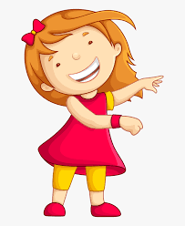Remember to have lots of fun! 

