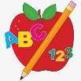Primary 2 Homework
Week Beginning: 12th January 2026
Here is a guide to help you for this week. You can choose how to organise your tasks to suit what works for you.
Please bring book bags to school every day. They will be collected in on a Friday as there will not be any homework at the weekend. If you feel you want to continue with some of the homework over the weekend, please just let me know. *Your child can use their homework jotter for any writing they do.
The Burns Cottage homework has also been posted on the blog and is in your child’s book bag.
 | Literacy | Numeracy
 | Joined Phonemes  This week we are learning about y (as in cry)  Get your child to make up the rainbow alphabet and make the words below. Can you add anymore?  fly shy cry sky why dry myself  Write your words three different ways – For example, pencil then coloured pencil then pen.  Write two sentences or more with the spelling words.  The joined phonemes your child should know are –  Group 1 – ay, ea (as in leaf), ow (as in snow)  Group 2 – ue (as in oo and you sounds), aw, oi  Group 3 – au, ew, ow (as in owl), ou  Group 4 - igh   | Time  Can you write a plan of your day either for during the week or the weekend using the appropriate times. An example is below.  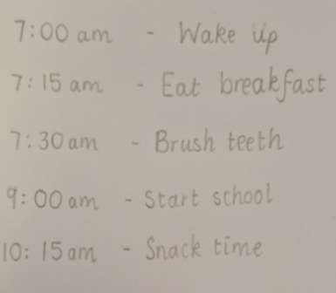  *Remember a.m. goes after the times in the morning and p.m. goes after the times in the afternoon/night.
Common Words

The new common words for Group 4 are -
fly Mr. two bring

Write/type/paint your words using fancy writing.
bring bring bring

Group 1 words - day away always today each ask year eat yellow grow again food

Group 2 words (so far) – blue best number other very took fast there their then some last

Group 3 words – because week keep when what soon many book how where now too round found wish men

Group 4 words – who right hand after

Keep working on the Word Wall sheets. Continue to practise any words from Group 1, 2 or 3 if they are still proving tricky.

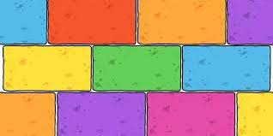
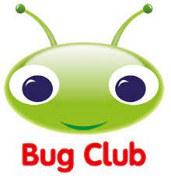
Your child will get their books home in their book bag when they have completed them in class.
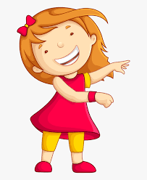Remember to have lots of fun! 