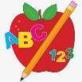Primary 2 Homework
Week Beginning: 5th January 2026
Here is a guide to help you for this week. You can choose how to organise your tasks to suit what works for you.
Please bring book bags to school every day. They will be collected in on a Friday as there will not be any homework at the weekend. If you feel you want to continue with some of the homework over the weekend, please just let me know. *Your child can use their homework jotter for any writing they do.
 | Literacy | Numeracy
 | Joined Phonemes  This week we are learning about igh.  Get your child to make up the rainbow alphabet. Use the letters with the new joined phoneme to make the words.  high right thigh light bright might  Read out each word to your child and get them to spell the word out loud. Use the letter names so that they remember the order of the letters. Write two sentences or more with the spelling words.  The joined phonemes your child should know are –  Group 1 – ay, ea (as in leaf), ow (as in snow)  Group 2 – ue (as in oo and you sounds), aw, oi  Group 3 – au, ew, ow (as in owl), ou   | Time  We are revising o’clock, half past, quarter past and quarter to times for digital and analogue clocks. Play the game below for the times specified.  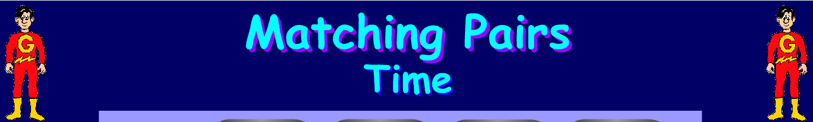  https://www.topmarks.co.uk/Flash.aspx?f=matchingpairstimev3  
Common Words

The new common words for Group 4 are -
who after hand right

Pyramid writing eg w
wh
who

Group 1 words - day away always today each ask year eat yellow grow again food

Group 2 words (so far) – blue best number other very took fast there their then some last

Group 3 words – because week keep when what soon many book how where now too round found wish men

Keep working on the Word Wall sheets. Continue to practise any words from Group 1, 2 or 3 if they are still proving tricky.

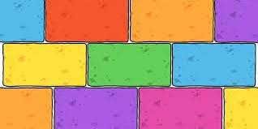
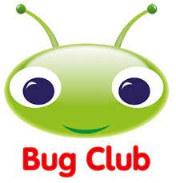
Your child will get their books home in their book bag when they have completed them in class.
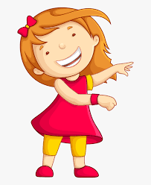Remember to have lots of fun! 

