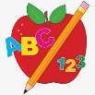Primary 2 Homework
Week Beginning: 8th December 2025
Here is a guide to help you for this week. You can choose how to organise your tasks to suit what works for you.

This is the last homework before the holidays.
We hope all families have a lovely Christmas!

 | Literacy | Numeracy
 | Joined Phonemes  This week we are consolidating Group 3 joined phonemes – au ew ow (as in brown) ou  Get your child to make up the rainbow alphabet and practise making, reading and writing words with these joined phonemes. Below are the spelling lists for each joined phoneme. Can you add any more?  au - fault haunt applaud pause because sauce  ew - drew few flew chew grew blew threw  ow - owl brown growl now crown allow cow  ou - count house round out shout sound mouse  *Challenge: Try to write at least one sentence for each of your four joined phonemes  Group 1– ay ea ow (as in snow)  Group 2 (covered so far) - ue aw, oi  Group 3 – au, ew, ow (as in brown)  Common Words  We are consolidating Group 3 common words -  because keep week when what many soon book now where how too round found wish men  Practise spelling your common words using letter names as not all words can be sounded out with the letter sounds.  There is a word wall in your child’s book bag to help them practise Group 2 common words. When they can read and spell the words, they can colour the brick in.    Continue to practise Group 1 and 2 words should your child need to.  Group 1 words - day away always today each ask year eat yellow grow again food  Group 2 words (so far) – blue best number other very took fast there their then some last | Time  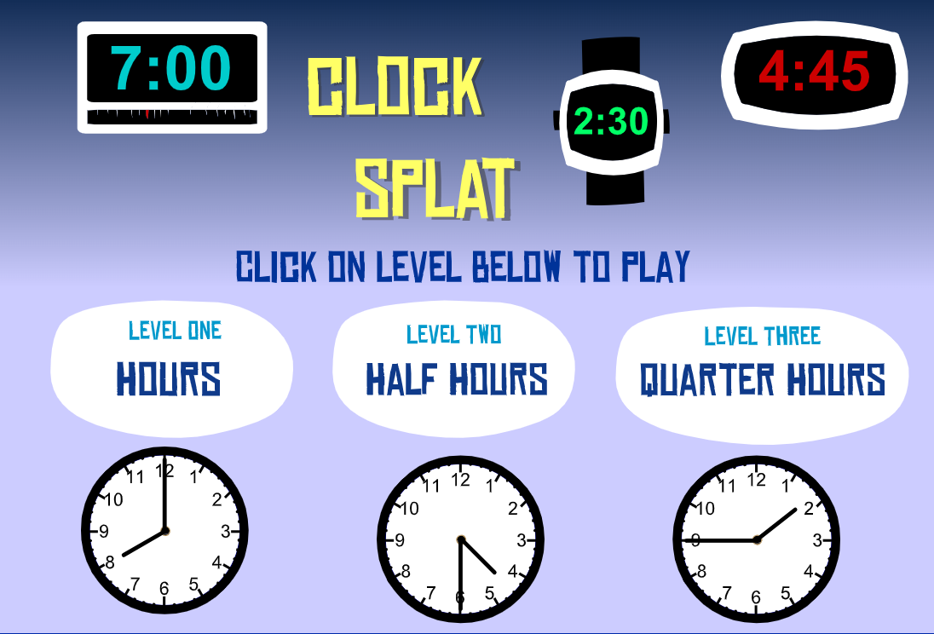  Click on the game below to play the o’clock and half past game.  https://www.sheppardsoftware.com/math/time/clock-splat-game/#google_vignette
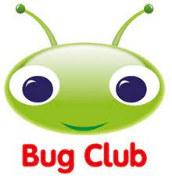
Your child will get their books home in their book bag when they have completed them in class.
Remember to have lots of fun! 

