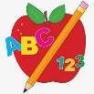Primary 2 Homework
Week Beginning: 1st December 2025
Here is a guide to help you for this week. You can choose how to organise your tasks to suit what works for you.
Please bring book bags to school every day. They will be collected in on a Friday as there will not be any homework at the weekend. If you feel you want to continue with some of the homework over the weekend, please just let me know. *Your child can use their homework jotter for any writing they do.
 | Literacy | Numeracy
 | Joined Phonemes  This week we are learning about ou.  Get your child to make up the rainbow alphabet. Use the letters with the new joined phoneme to make the words.  count house round out shout sound mouse  Write/type/paint your words using fancy writing.  count count count  Do this for each of your spelling words.  * Challenge: Your child can write sentences with each of their words if they wish. Try to write at least one sentence.  Group 1– ay ea ow (as in snow)  Group 2 (covered so far) - ue aw, oi  Group 3 – au, ew, ow (as in brown)   | Time  Click on the game below to play the o’clock game using analogue and digital clocks.  https://www.teachingtime.co.uk/tasters/Ihaveclock60f.html  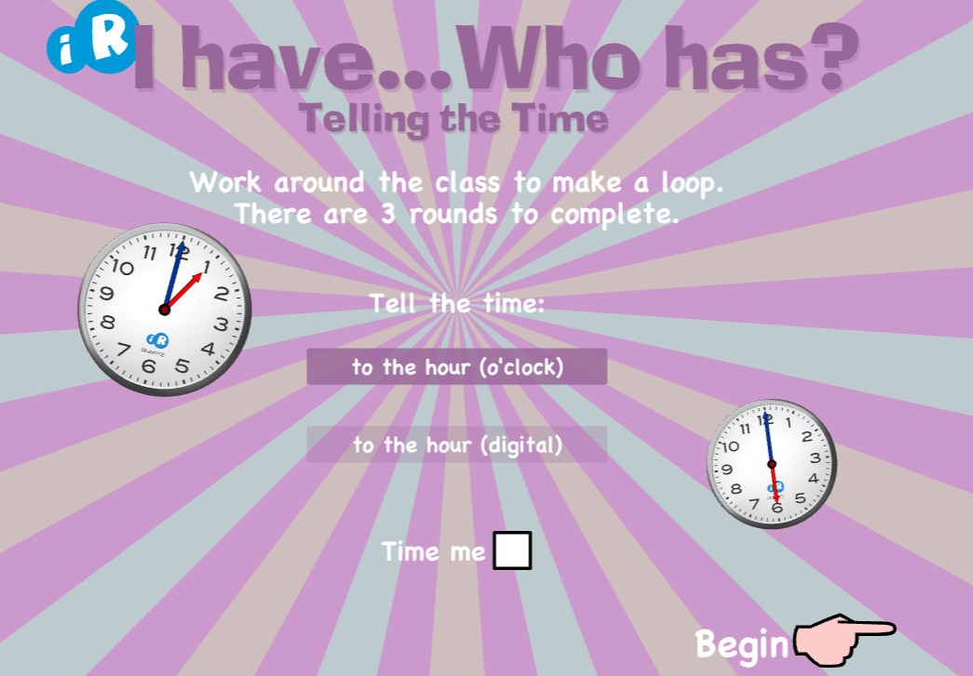  Click on the game below to play the o’clock and half past game.  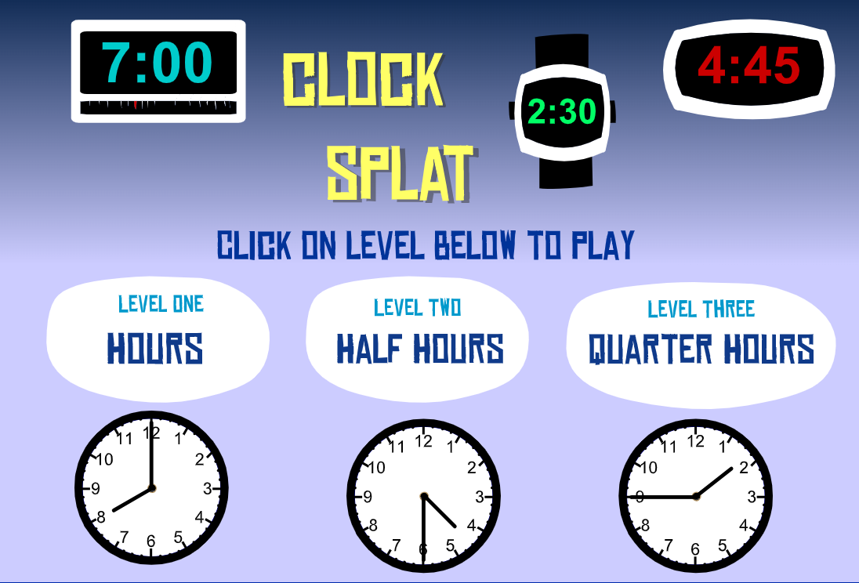  https://www.sheppardsoftware.com/math/time/clock-splat-game/#google_vignette
Common Words

The new common words for Group 3 this week are -
round found wish men

As a couple of your words fit in with the spelling focus, complete the same task for your common words too.

Group 1 words - day away always today each ask year eat yellow grow again food

Group 2 words (so far) – blue best number other very took fast there their then some last

Group 3 words – because keep week when what many soon book now where how too

*Continue to practise all words to make sure your child can read and spell them confidently.
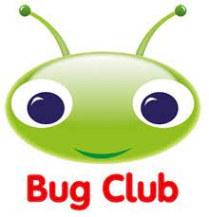
Your child will get their books home in their book bag when they have completed them in class.
Remember to have lots of fun! 

