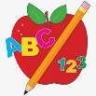Primary 2 Homework
Week Beginning: 24th November 2025
Here is a guide to help you for this week. You can choose how to organise your tasks to suit what works for you.
Please bring book bags to school every day. They will be collected in on a Friday as there will not be any homework at the weekend. If you feel you want to continue with some of the homework over the weekend, please just let me know. *Your child can use their homework jotter for any writing they do.
 | Literacy | Numeracy
 | Joined Phonemes  This week we are learning about ow (as in owl).  Get your child to make up the rainbow alphabet. Use the letters with the new joined phoneme to make the words.  owl brown growl now crown allow cow  Draw a funny picture using as many spelling words as you can. Label your picture. For example -  crown  brown owl 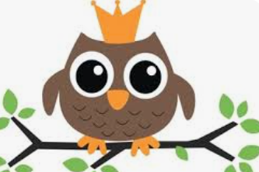  * Challenge: Your child can write sentences with each of their words if they wish. Try to write at least one sentence.  Group 1– ay ea ow (as in snow)  Group 2 (covered so far) - ue aw, oi  Group 3 – au, ew | Time  We are currently revising o’clock times for digital and analogue clocks, before we move onto other times. Click on the link below to play the telling the time game, click option 1 (o’clock times).  https://mathsframe.co.uk/en/resources/resource/116/telling-the-time  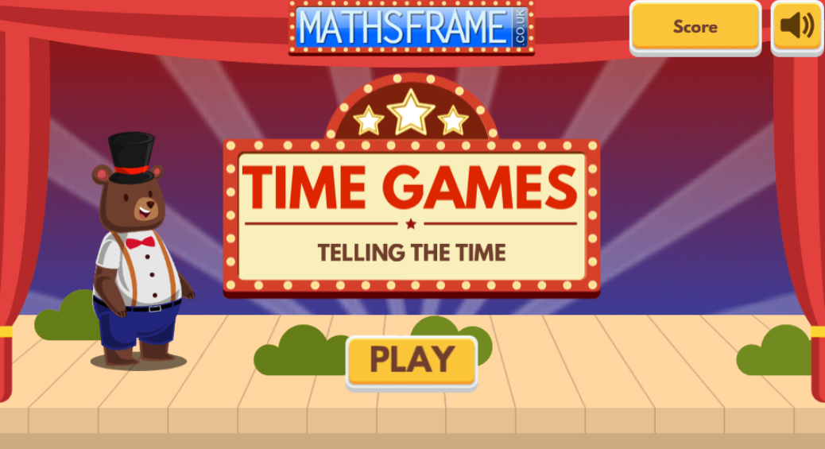  Click on the links below to sing the days of the week and months of the year songs.  https://www.youtube.com/watch?v=mXMofxtDPUQ&list=RDmXMofxtDPUQ&start_radio=1  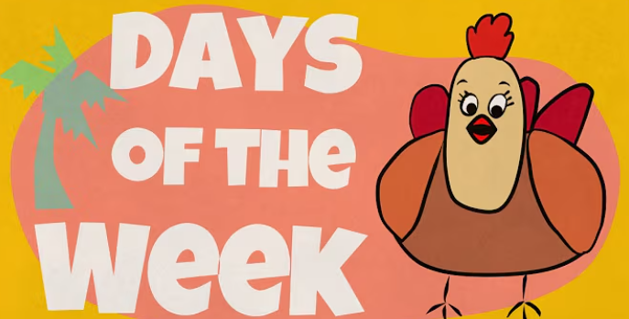  https://www.youtube.com/watch?v=Fe9bnYRzFvk&list=RDFe9bnYRzFvk&start_radio=1  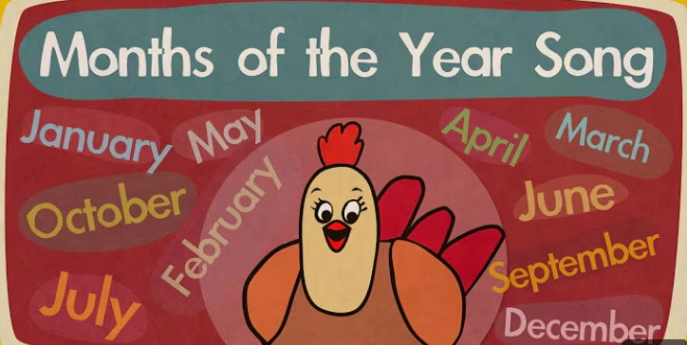
Common Words

The new common words for Group 3 this week are -
how where now too

Write your words three times using three different methods, eg. pencil, coloured pencil, black pen, coloured pen, crayon, etc.

Group 1 words - day away always today each ask year eat yellow grow again food

Group 2 words (so far) – blue best number other very took fast there their then some last

Group 3 words – because week keep when what soon many book

*Continue to practise all words to make sure your child can read and spell them confidently.
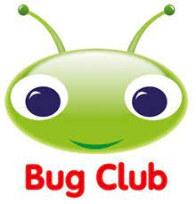
Your child will get their books home in their book bag when they have completed them in class.
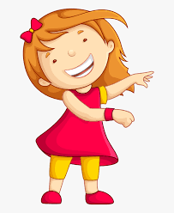Remember to have lots of fun! 