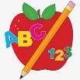Primary 2 Homework
Week Beginning: 17th November 2025
Here is a guide to help you for this week. You can choose how to organise your tasks to suit what works for you.
Please bring book bags to school every day. They will be collected in on a Friday as there will not be any homework at the weekend. If you feel you want to continue with some of the homework over the weekend, please just let me know. *Your child can use their homework jotter for any writing they do.
 | Literacy | Numeracy
 | Joined Phonemes  This week we are learning about ew.  Get your child to make up the rainbow alphabet. Use the letters with the new joined phoneme to make the words.  drew few flew chew grew blew threw  Practise writing your spellings words. Write the words with a normal writing pencil but write the new joined phoneme in a different colour to highlight it, eg. drew.  * Challenge: Your child can write sentences with each of their words if they wish. Try to write at least one sentence.  Group 1– ay ea ow (as in snow)  Group 2 (covered so far) - ue aw, oi  Group 3 - au   | Numbers to 100  Play the game below to practise rounding numbers to the nearest ten (numbers up to 99). You can practise this with or without a number line.  https://www.topmarks.co.uk/maths-games/rocket-rounding  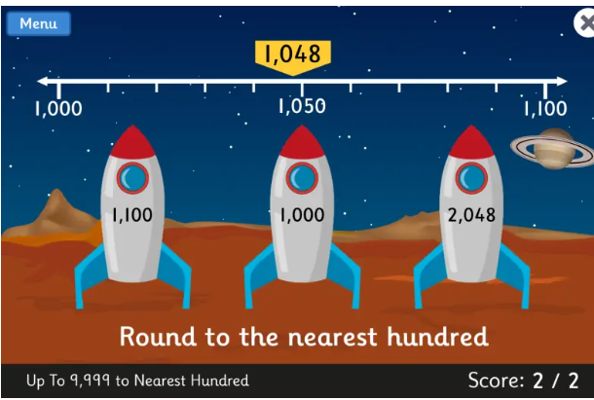
Common Words

The new common words for Group 3 this week are -
what many soon book

Try writing or typing your words in different styles. Eg. many many many many

Group 1 words - day away always today each ask year eat yellow grow again food

Group 2 words (so far) – blue best number other very took fast there their then some last

Group 3 words – because week keep when

*Continue to practise these words to make sure your child can read and spell them.
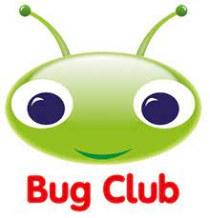
Your child will get their books home in their book bag when they have completed them in class.
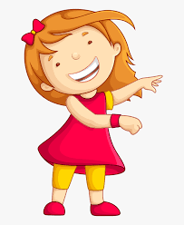Remember to have lots of fun! 

