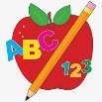Primary 2 Homework
Week Beginning: 10th November 2025
Here is a guide to help you for this week. You can choose how to organise your tasks to suit what works for you.
Please bring book bags to school every day. They will be collected in on a Friday as there will not be any homework at the weekend. If you feel you want to continue with some of the homework over the weekend, please just let me know. *Your child can use their homework jotter for any writing they do.
 | Literacy | Numeracy
 | Joined Phonemes  This week we are learning about au.  Get your child to make up the rainbow alphabet. Use the letters with the new joined phoneme to make the words.  fault haunt applaud pause because sauce  Write your words three times in a row. Once with a pencil, once with a coloured pencil and once in pen.  fault fault fault  * Challenge: Your child can write sentences with each of their words if they wish. Try to write at least one sentence.  Group 1– ay ea ow (as in snow)  Group 2 (covered so far) - ue aw, oi   | Numbers to 100  Play the game below to find half of a number.  In the ‘Number Range’ section start with ‘Halves to 10’ then move onto the next section(s) if you are looking for a challenge.  *Remember doubles are two halves of a number added together.  https://www.topmarks.co.uk/maths-games/hit-the-button  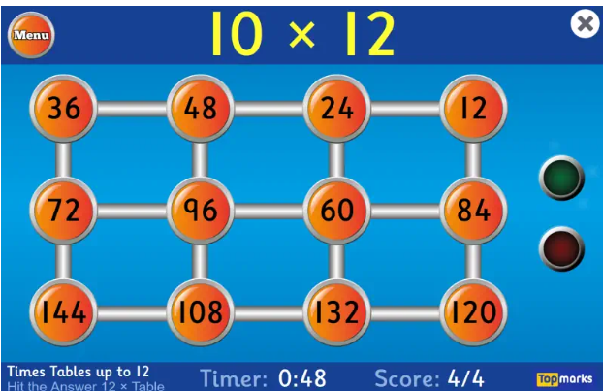
Common Words

The new common words for Group 3 this week are -
because week keep when

*Your child can do the same activity that they are doing for their spelling words to practise these words.

Group 1 words - day away always today each ask year eat yellow grow again food

Group 2 words (so far) – blue best number other very took fast there their then some last

*Continue to practise these words to make sure your child can read and spell them.
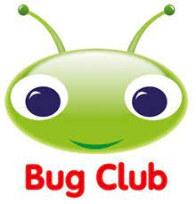
Your child will get their books home in their book bag when they have completed them in class.
Remember to have lots of fun! 

