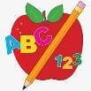Primary 2 Homework
Week Beginning: 3rd November 2025
Here is a guide to help you for this week. You can choose how to organise your tasks to suit what works for you.
Please bring book bags to school every day. They will be collected in on a Friday as there will not be any homework at the weekend. If you feel you want to continue with some of the homework over the weekend, please just let me know. *Your child can use their homework jotter for any writing they do.
 | Literacy | Numeracy
 | Joined Phonemes  This week we are consolidating Group 2 joined phonemes – ue aw oi  Get your child to make up the rainbow alphabet and practise making, reading and writing words with these joined phonemes. Below are the spelling lists for each joined phoneme. Can you add any more?  ue – blue glue true clue Sue  aw- saw jaw draw hawk crawl awful  oi – boil spoil foil toilet join moist  *Challenge: Try to write at least one sentence for each of your three joined phonemes   | 2D shapes  Play the game below to identify the shapes – circle, square, triangle, rectangle, pentagon and hexagon. Discuss the name of the shape, how many sides and how many corners (vertices). Choose Level 1.  https://www.topmarks.co.uk/shapes/2d-shape-reveal  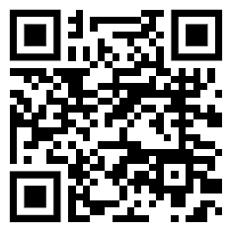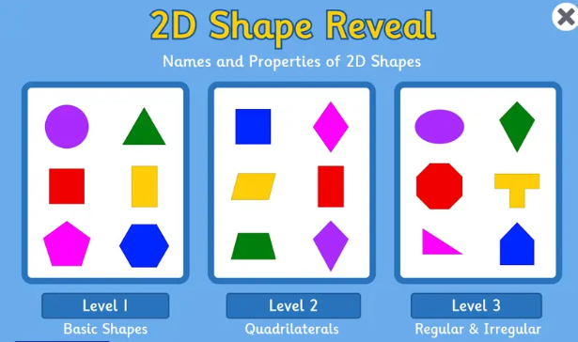
Common Words

We are consolidating Group 2 common words -
blue best number other very took fast there their then some last

Practise spelling your common words using letter names as not all words can be sounded out with the letter sounds.

There is a word wall in your child’s book bag to help them practise Group 2 common words. When they can read and spell the words, they can colour the brick in.

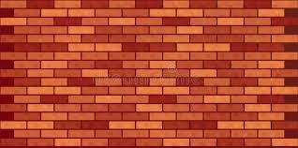

Continue to practise Group 1 words.
Group 1 words - day away always today each ask year eat yellow grow again food

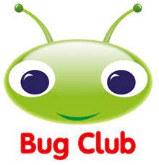
Your child will get their books home in their book bag when they have completed them in class.
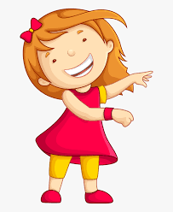Remember to have lots of fun! 