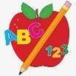Primary 2 Homework
Week Beginning: 27th October 2025
Here is a guide to help you for this week. You can choose how to organise your tasks to suit what works for you.
Please bring book bags to school every day. They will be collected in on a Friday as there will not be any homework at the weekend. If you feel you want to continue with some of the homework over the weekend, please just let me know. *Your child can use their homework jotter for any writing they do.
 | Literacy | Numeracy
 | Joined Phonemes  This week we are learning about oi.  Get your child to make up the rainbow alphabet. Use the letters with the new joined phoneme to make the words.  boil spoil foil toilet join moist  Write your words across and down the way, eg.  s p o i l  p  o  i  l  * Challenge: Your child can write sentences with all their words if they wish. Try to write at least one sentence.  Group 1– ay ea ow (as in snow)  Group 2 (covered so far) - ue aw | Numbers to 100  Click the song below to practise counting in 5s.  https://www.youtube.com/watch?v=EemjeA2Djjw&list=RDEemjeA2Djjw&start_radio=1  Can you write down all the numbers counting in 5s from 0 to 50 or 0 to 100?  Can you do the same counting in 2s? Try starting with an odd number up to 50/100 then try starting with an even number. (0 2 4 6 etc or 1 3 5 etc).
Common Words

The new common words for this week are

their some then last

Practise writing your words in lower case and upper case letters – their THEIR

Group 1 words - day away always today each ask year eat yellow grow again food

Group 2 words (so far) – blue best number other very took fast there

*Continue to practise these words to make sure your child can read and spell them.
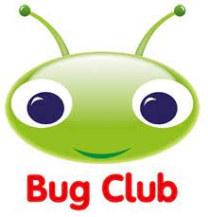
Your child will get their books home in their book bag when they have completed them in class.
Remember to have lots of fun! 

