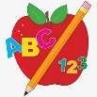Primary 2 Homework
Week Beginning: 20th October 2025
Here is a guide to help you for this week. You can choose how to organise your tasks to suit what works for you.
Please bring book bags to school every day. They will be collected in on a Friday as there will not be any homework at the weekend. If you feel you want to continue with some of the homework over the weekend, please just let me know. *Your child can use their homework jotter for any writing they do.
 | Literacy | Numeracy
 | Joined Phonemes  This week we are learning about aw.  Get your child to make up the rainbow alphabet. Use the letters with the new joined phonemes to make the words.  saw jaw draw hawk crawl awful  Your child can practise spelling their words out loud to someone then write them down. They should count how many letters they have when they spell them out loud and check that that is how many they have written.  * Challenge: Your child can write sentences with their words if they wish.   | Numbers to 100  Play the game below to explore tens and ones (units) - click on T O.  https://www.topmarks.co.uk/place-value/place-value-charts  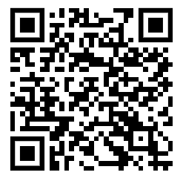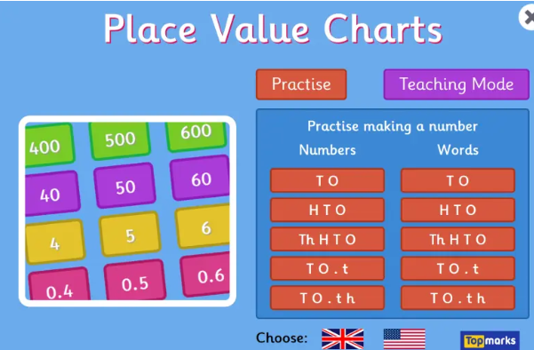  Play the game below to explore odd and even numbers.  https://www.topmarks.co.uk/learning-to-count/coconut-odd-or-even  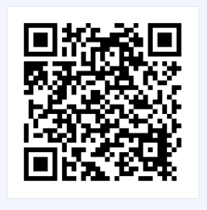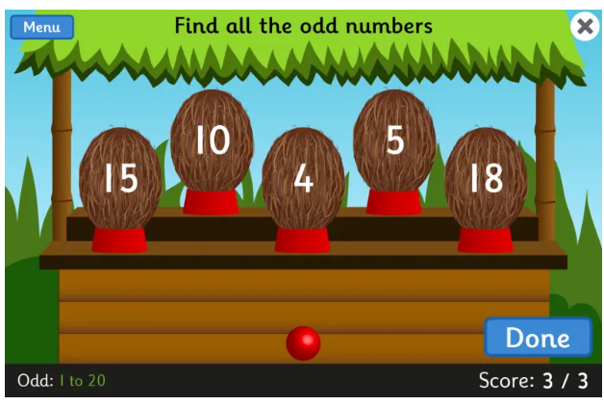
Common Words

The new common words for this week are -
very took fast there

*Your child can do the same activity that they are doing for their spelling words.

Group 1 words - day away always today each ask year eat yellow grow again food

Group 2 words – blue best number other

*Continue to practise these words to make sure your child can read and spell them.
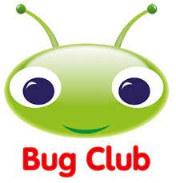
Your child will get their books home in their book bag when they have completed them in class.
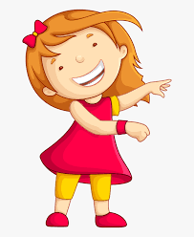Remember to have lots of fun! 