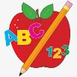**Primary 2 Homework** 

**Week Beginning: 6th October 2025**

Here is a guide to help you for this week. You can choose how to organise your tasks to suit what works for you.

Please bring book bags to school every day. They will be collected in on a Friday as there will not be any homework at the weekend. If you feel you want to continue with some of the homework over the weekend, please just let me know. \***Your child can use their homework jotter for any writing they do.**

|  |  |  |
| --- | --- | --- |
|  | Literacy | Numeracy |
|  | **Joined Phonemes**  This week we are learning about ue.  Get your child to make up the rainbow alphabet. Use the letters with the new joined phoneme to make the words.  blue glue true clue Sue  Pyramid Writing – **b**  **bl**  **blu**  **blue**  Do this for each of your spelling words.  **\* Challenge: Your child can write sentences with their words if they wish.** | **Numbers to 100**  Use the 100 square to look for smaller and larger numbers – eg. find me a number smaller/larger than …. **or** out of two numbers which one is smaller/larger?  Play the game below for your child to learn more about counting in 10s.  <https://www.topmarks.co.uk/ordering-and-sequencing/coconut-ordering>    Click the bar ‘Up to 100 (tens)’ once into the game. |
|  | **Common Words**  The new common words for this week are  blue best number other  Cut out letters from magazines/newspapers to make these words.  **Continue to practise Group 1 words to make sure your child can read and spell them.**  Group 1 words - day away always today each ask year eat yellow grow again food |  |
|  | Your child will get their books home in their book bag when they have completed them in class. |  |

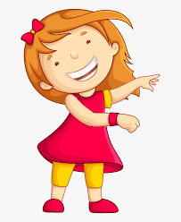Remember to have lots of fun! [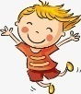](https://www.google.co.uk/url?sa=i&url=https://www.clipart.email/clipart/child-happy-clipart-147083.html&psig=AOvVaw15KElXbPSE2k0Wq8C2DJHG&ust=1589482978254000&source=images&cd=vfe&ved=0CAIQjRxqFwoTCKjumtTDsekCFQAAAAAdAAAAABAL)