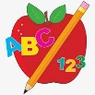**Primary 2 Homework** 

**Week Beginning: 15th September 2025**

Here is a guide to help you for this week. You can choose how to organise your tasks to suit what works for you.

Please bring book bags to school every day. They will be collected in on a Friday as there will not be any homework at the weekend. If you feel you want to continue with some of the homework over the weekend, please just let me know. \***Your child can use their homework jotter for any writing they do.**

|  |  |  |
| --- | --- | --- |
|  | Literacy | Numeracy |
|  | **Joined Phonemes**  Your child is learning new P2 joined phonemes. This week we are learning about ea.  Get your child to make up the rainbow alphabet. Use the letters with the new joined phonemes to make the words.  speak clean steal team stream eat wheat  Choose a colour for your new joined phoneme and practise writing your spelling words **and common words** (below). For example, if you are writing team, pick a colour for the **ea** and write the rest of your word with a normal writing pencil – **team**.  **\*Challenge: Your child can write sentences with their words if they wish.** | **Numbers to 100**  The children are exploring numbers to 100.  Your child will have their 100 square in their book bags. Ask your child to point to different numbers. Ask your child to find the number/numbers before, after and in-between. |
|  | **Common Words**  **The new common words for this week are**  each ask year eat  *Most of these words fit in with your spelling activity as they use the new joined phoneme. |  |
|  | Your child will get their books home in their book bag when they have completed them in class. |  |

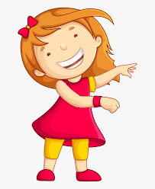Remember to have lots of fun! [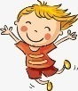](https://www.google.co.uk/url?sa=i&url=https://www.clipart.email/clipart/child-happy-clipart-147083.html&psig=AOvVaw15KElXbPSE2k0Wq8C2DJHG&ust=1589482978254000&source=images&cd=vfe&ved=0CAIQjRxqFwoTCKjumtTDsekCFQAAAAAdAAAAABAL)