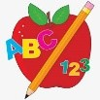**Primary 1 Homework** 

**Week Beginning: 24th September 2024**

Here is a guide to help you for this week.  You can choose how to organise your tasks to suit what works for you.

Please bring book bags to school every day.  They will be collected in on a Friday as there will not be any homework at the weekend.  If you feel you want to continue some of the homework over the weekend, please ask for your child’s book bag.

|  |  |  |
| --- | --- | --- |
|  | Literacy | Numeracy |
|  | **Phonics**    Each week your child will get new letters in the form of milk bottle lids.  Vowels are red and consonants are blue.  They need to know the letter sound, name and write the letter correctly. At this stage this may be all your child can manage. Letters can be written in homework jotters using coloured pencils, pen, Mummy’s special pen (anything to encourage them to write).  Challenge  In class we have been trying to make, read and write words with the letters we have learned using magnetic letters. The children are trying very hard with this and can continue to do it at home with their milk bottle lid letters. This is called blending and can be quite tricky to begin with.  The letters that should be in their book bag are –  a t s m i    C:\Users\dronprbradyj\AppData\Local\Microsoft\Windows\INetCache\Content.MSO\D32619B9.tmp    Below is a video below for you to watch to help support your child with blending. Keep scrolling!    <https://watchkin.com/ce7676932f> | Your child will have number cards in their book bag. Ask your child to put the cards in order from 0 – 10 and 10 – 0. Ask questions like what comes before, after and in-between a certain number/numbers. You could also try asking them to find the number 1 more than or 1 less than. They could find objects around the house to match quantities to numbers.    C:\Users\dronprbradyj\AppData\Local\Microsoft\Windows\INetCache\Content.MSO\54F6DD2F.tmp |
|  | **If your child is writing, please encourage them to hold their pencil correctly.**    C:\Users\dronprbradyj\AppData\Local\Microsoft\Windows\INetCache\Content.MSO\69D64E15.tmp |  |

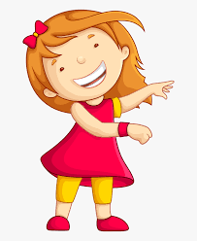Remember to have lots of fun!   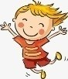

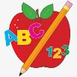**First Level Homework** 

**Week Beginning: 24th September 2024**

Here is a guide to help you for this week. You can choose how to organise your tasks to suit what works for you.

Please bring book bags to school every day. They will be collected in on a Friday as there will not be any homework at the weekend. If you feel you want to continue some of the homework over the weekend, please ask for your child’s book bag.

\***Your child can use their homework jotter for any writing they do.**

|  |  |  |
| --- | --- | --- |
|  | Literacy | Numeracy |
|  | **Joined Phonemes**  Your child is learning new P2 joined phonemes. This week we are learning about ow.  Get your child to make up the rainbow alphabet. Use the letters with the new joined phonemes to make the words.  low grow throw follow shallow show  Write each of your spelling words three times. Use a pencil first, then a coloured pencil and lastly in pen.  **\*If your child wants a challenge they can write a sentence with the words. This is not required but available to do if they wish.** | **Numbers to 100**  The children are exploring numbers to 100.  Click on the link below to play Chopper Squad where your child can practise one more/less and ten more/less.  <https://www.topmarks.co.uk/learning-to-count/chopper-squad>    Click on the link below to play Caterpillar ordering. Go to Sequencing and click numbers to 100  <https://www.topmarks.co.uk/ordering-and-sequencing/caterpillar-ordering> |
|  | **Common Words**  **The new common words for this week are**  yellow grow again food  Look for your common words in books, magazines, posters, etc. Note down how many times you see them. |  |
|  | Your child will get their books home in their book bag when they have completed them in class. |  |

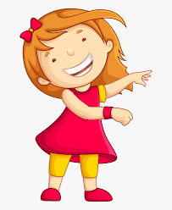Remember to have lots of fun! [](https://www.google.co.uk/url?sa=i&url=https://www.clipart.email/clipart/child-happy-clipart-147083.html&psig=AOvVaw15KElXbPSE2k0Wq8C2DJHG&ust=1589482978254000&source=images&cd=vfe&ved=0CAIQjRxqFwoTCKjumtTDsekCFQAAAAAdAAAAABAL)