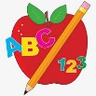Primary 1 Homework
Week Beginning: 29th April 2024
Here is a guide to help you for this week. You can choose how to organise your tasks to suit what works for you.
Please bring book bags to school every day.
 | Literacy | Numeracy
 | Phonics  We have learned a new joined phoneme (digraph) – wh.  Use the letter lids to make as many words as you can. You can draw pictures for the words if you wish.  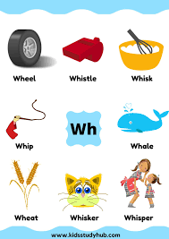 | Money  Explore and identify all coins in the house. Try to make totals with a variety of coins. Play shop.  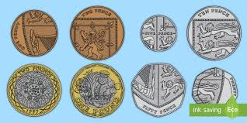
Common Words

New words – out now new

Continue to work on previous words should your child still need to practise reading/spelling them.
Group 1 – a at the I is it an and in
Group 2 – am as me did he we my can into
Group 3 – go got get if for on be but you
Group 4 – was went his have just to your by only dad are not
Group 5 - she come from this that then with us so much of or
Group 6 - old do going

Reading
Your child may bring a reading book home. Please encourage them to point to the words as they read.

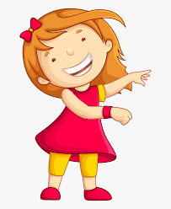Remember to have lots of fun!
Primary 2 Homework
Week Beginning: 29th April 2024
Here is a guide to help you for this week. You can choose how to organise your tasks to suit what works for you.
Please bring book bags to school every day.
*Your child can use their homework jotter for any writing they do.
 | Literacy | Numeracy
 | Phonemes  This is a consolidation week.  Practise all of the joined/split phonemes. Turn all of the letter lids over. Ask your child to turn one over, say the phoneme and come up with three words for that joined phoneme. Write them down.  Choose some of your words to make sentences with.  The joined phonemes your child should know are –  Group 1 – ay, ea (as in leaf), ow (as in snow)  Group 2 – ue (as in oo and you sounds), aw, oi  Group 3 – au, ew, ow (as in owl), ou  Group 4 – igh, y (as in cry), i-e (as in side), o-e (as in home).  Group 5 – a-e (as in cake), u-e (as in cube), e-e (as in here), ss, ll | Money  Click on the link below to practise adding coins together or giving change.  https://www.topmarks.co.uk/money/toy-shop-money  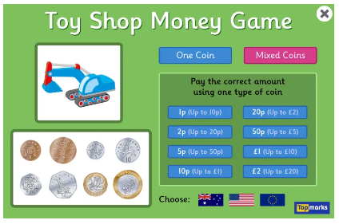  Play shop and ask your child to make totals with a variety of coins and work out what change should be given.
Common Words

This is a consolidation week.

Use the word walls to practise reading and spelling the common words.
Ask your child to read the words to you and you write them down. Your child can mark them. Then read them to your child and get them to write them down.

These are the words taught so far -
Group 1 words - day away always today each ask year eat yellow grow again food

Group 2 words – blue best number other very took fast there then some their last

Group 3 words – because week keep when what many soon book how where now too round found wish men

Group 4 words – who after hand right fly bring Mr. two five time life line home more school Mrs.

Group 5 words – take gave cold don’t every find want girl father head mother jump
four miss never these will well fell call

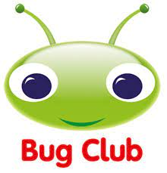
Your child will get their books home in their book bag when they have completed them in class.
Remember to have lots of fun!

