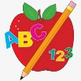Primary 1 Homework
Week Beginning: 22nd April 2024
Here is a guide to help you for this week. You can choose how to organise your tasks to suit what works for you.
Please bring book bags to school every day.
 | Literacy | Numeracy
 | Phonics  We have learned a new joined phoneme (digraph) – ng.  Use the letter lids to make as many words as you can. You can draw pictures for the words if you wish.  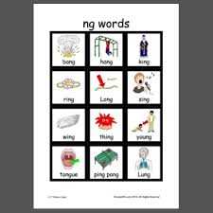 | Subtraction within 10  We are learning about subtraction within 10. Click on the link below.  https://www.topmarks.co.uk/subtraction/subtraction-to-10  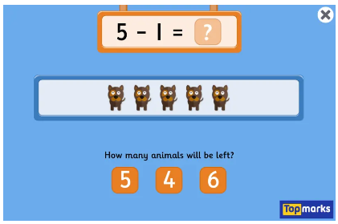
Common Words

New words – old do going

Continue to work on previous words should your child still need to practise reading/spelling them.
Group 1 – a at the I is it an and in
Group 2 – am as me did he we my can into
Group 3 – go got get if for on be but you
Group 4 – was went his have just to your by only dad are not
Group 5 - she come from this that then with us so much of or

*Group 5 word wall is in your child’s book bag.

Reading
Your child may bring a reading book home. Please encourage them to point to the words as they read.

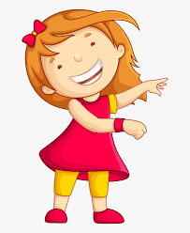Remember to have lots of fun!
Primary 2 Homework
Week Beginning: 22nd April 2024
Here is a guide to help you for this week. You can choose how to organise your tasks to suit what works for you.
Please bring book bags to school every day.
*Your child can use their homework jotter for any writing they do.
 | Literacy | Numeracy
 | Split Phoneme  This week’s new joined phoneme is ll (as in hill).  Remember this joined phoneme does not appear at the start of a word.  This week’s spelling words are –  well spill fill dull drill allow shallow  Write your words across and down, eg.  w e l l  e  l  l  *Challenge – Can you join all of your words together like a crossword puzzle?  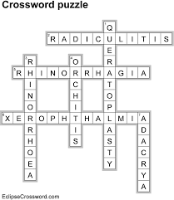  Choose some of your words to make sentences with.  The joined phonemes your child should know are –  Group 1 – ay, ea (as in leaf), ow (as in snow)  Group 2 – ue (as in oo and you sounds), aw, oi  Group 3 – au, ew, ow (as in owl), ou  Group 4 – igh, y (as in cry), i-e (as in side), o-e (as in home).  Group 5 – a-e (as in cake), u-e (as in cube), e-e (as in here), ss. | Subtraction within 20  Click on the link below.  https://www.topmarks.co.uk/maths-games/robot-more-or-less  The children can use the number line or hide it and use their strategies.
Common Words

This week’s common words are –

well will fell call

Use these words with the spelling task as they also use the new joined phoneme.

These are the words taught so far -
Group 1 words - day away always today each ask year eat yellow grow again food

Group 2 words – blue best number other very took fast there then some their last

Group 3 words – because week keep when what many soon book how where now too round found wish men

Group 4 words – who after hand right fly bring Mr. two five time life line home more school Mrs.

Group 5 words – take gave cold don’t every find want girl father head mother jump
four miss never these

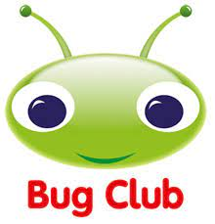
Your child will get their books home in their book bag when they have completed them in class.
Remember to have lots of fun!

