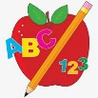Primary 1 Homework
Week Beginning: 18th March 2024
Here is a guide to help you for this week. You can choose how to organise your tasks to suit what works for you.
Please bring book bags to school every day.
 | Literacy | Numeracy
 | Phonics  We have learned a new joined phoneme (digraph) – th.  This makes a hard sound as in ‘then’ and a soft sound as in ‘thin’.  Use the letter lids to make as many words as you can. You can draw pictures for the words if you wish.  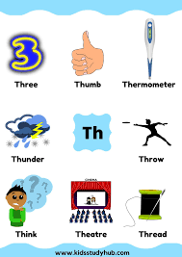 | Numbers to 20  There is a number line in your child’s book bag. Ask your child to find the number before, in-between, after, one more than, two more than, one less than, two less than.  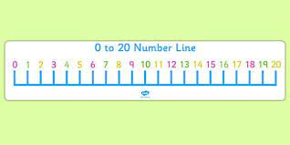
Common Words

We have started Group 5 Common Words.

New words – this that then

Continue to work on previous words should your child still need to practise reading/spelling them.
Group 1 – a at the I is it an and in
Group 2 – am as me did he we my can into
Group 3 – go got get if for on be but you
Group 4 – was went his have just to your by only dad are not
Group 5 - she come from

Reading
Your child may bring a reading book home. Please encourage them to point to the words as they read.

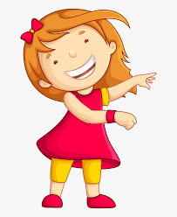Remember to have lots of fun! 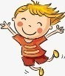

Primary 2 Homework
Week Beginning: 18th March 2024
Here is a guide to help you for this week. You can choose how to organise your tasks to suit what works for you.
Please bring book bags to school every day.
*Your child can use their homework jotter for any writing they do.
 | Literacy | Numeracy
 | Split Phoneme  This week’s phoneme is e-e (eg. here).  Click on the link below to find out about the job of ‘Magic e’ for e-e.  https://www.youtube.com/watch?v=Ts8Jsq7a9qQ  This week’s spelling words are –  these here eve complete even  How many e-e words can you make? Write them down in your jotter. Use the guide you already have in your book bag to diacritically mark them.  Choose some of your words to make sentences with.  The joined phonemes your child should know are –  Group 1 – ay, ea (as in leaf), ow (as in snow)  Group 2 – ue (as in oo and you sounds), aw, oi  Group 3 – au, ew, ow (as in owl), ou  Group 4 – igh, y (as in cry), i-e (as in side), o-e (as in home).  Group 5 – a-e (as in cake), u-e (as in cube) | Addition to 20  Click on the link below. Click Level 2.  https://www.sheppardsoftware.com/math/addition/fruit-splat-game/  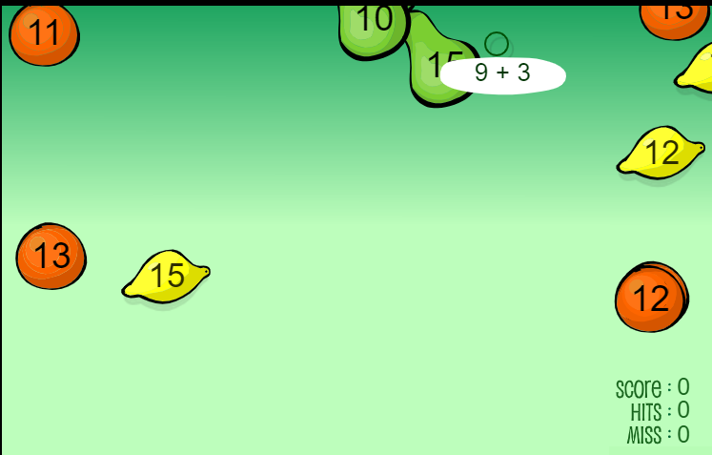
Common Words

This week’s common words are –

father head mother jump

Write the words in lowercase letters and then in capitals (father FATHER).

These are the words taught so far -
Group 1 words - day away always today each ask year eat yellow grow again food

Group 2 words – blue best number other very took fast there then some their last

Group 3 words – because week keep when what many soon book how where now too round found wish men

Group 4 words – who after hand right fly bring Mr. two five time life line home more school Mrs.

Group 5 words – take gave cold don’t every find want girl
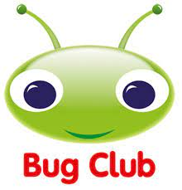
Your child will get their books home in their book bag when they have completed them in class.
Remember to have lots of fun!

