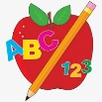Primary 1 Homework
Week Beginning: 11th March 2024
Here is a guide to help you for this week. You can choose how to organise your tasks to suit what works for you.
Please bring book bags to school every day.
 | Literacy | Numeracy
 | Phonics  We are continuing to work on sh.  Click on the link below to play Forest phonics.  Choose sh.  https://ictgames.com/mobilePage/forestPhonics/index.html  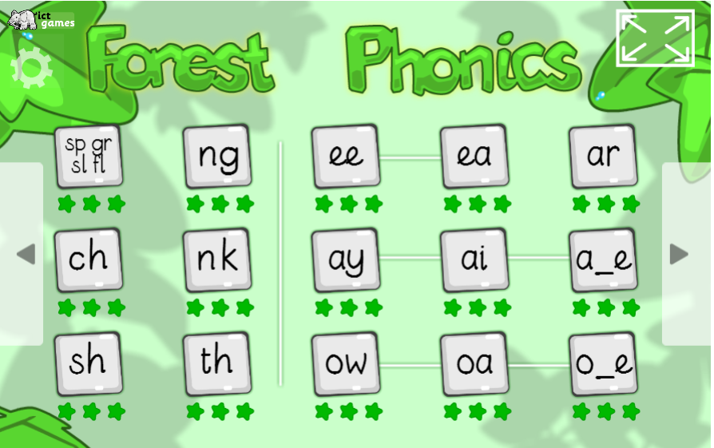 | Numbers to 20  Click on the link below to find the missing numbers in a sequence.  https://pbskids.org/curiousgeorge/busyday/apples/  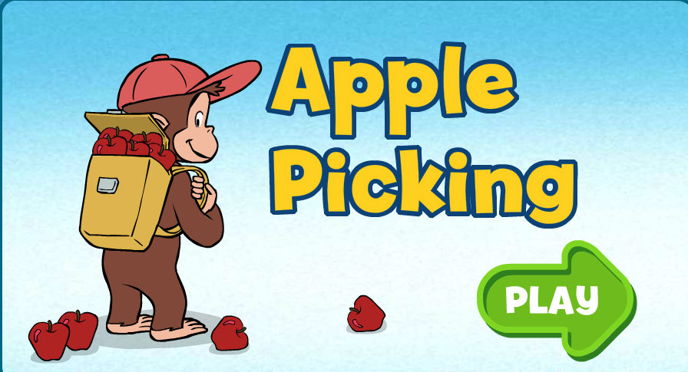
Common Words

We have started Group 5 Common Words.

New words – she come from

Continue to work on previous words should your child still need to practise reading/spelling them.
Group 1 – a at the I is it an and in
Group 2 – am as me did he we my can into
Group 3 – go got get if for on be but you
Group 4 – was went his have just to your by only dad are not

Reading
Your child may bring a reading book home. Please encourage them to point to the words as they read.

Remember to have lots of fun!

Primary 2 Homework
Week Beginning: 11th March 2024
Here is a guide to help you for this week. You can choose how to organise your tasks to suit what works for you.
Please bring book bags to school every day.
*Your child can use their homework jotter for any writing they do.
 | Literacy | Numeracy
 | Split Phoneme  This week’s phoneme is u-e (eg. clue).  Click on the link below to find out about the job of ‘Magic e’ for u-e.  https://www.youtube.com/watch?v=cl82zAHzkmM  This week’s spelling words are –  June rule ruler rude flute tune  Practise making and writing your spelling words.  Choose some of your words to make sentences with. Draw a picture to match your sentence. Remember your sentence may end in a full stop, question mark or exclamation mark, depending on what your write.  The joined phonemes your child should know are –  Group 1 – ay, ea (as in leaf), ow (as in snow)  Group 2 – ue (as in oo and you sounds), aw, oi  Group 3 – au, ew, ow (as in owl), ou  Group 4 – igh, y (as in cry), i-e (as in side), o-e (as in home).  Group 5 – a-e (as in cake) | Addition to 20  Click on the link below to practise addition to 20. Once in click Up to 20 then Add 1 to 10.  https://www.topmarks.co.uk/maths-games/robot-more-or-less  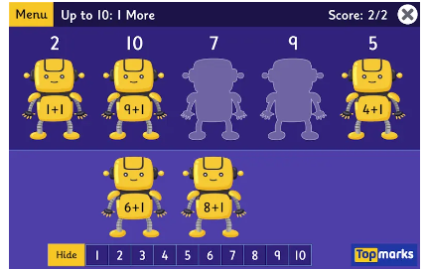
Common Words

This week’s common words are –

every find want girl

Try writing these words in different styles eg. every every every every
You can write with black or different colours, paint or type it. You choose.

These are the words taught so far -
Group 1 words - day away always today each ask year eat yellow grow again food

Group 2 words – blue best number other very took fast there then some their last

Group 3 words – because week keep when what many soon book how where now too round found wish men

Group 4 words – who after hand right fly bring Mr. two five time life line home more school Mrs.
 | Your child will get their books home in their book bag when they have completed them in class.
Remember to have lots of fun!

