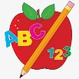Primary 1 Homework
Week Beginning: 4th March 2024
Here is a guide to help you for this week. You can choose how to organise your tasks to suit what works for you.
Please bring book bags to school every day.
 | Literacy | Numeracy
 | Phonics  Your child should now have all the letters of the alphabet. If there are any missing letters let us know and we will replace them.  This week we met a new joined phoneme (digraph).  This is when two letters come together to make one sound.  This week’s new joined phoneme is sh.  Your child has a green letter lid with sh on it. Try to make as many words as you can with sh at the beginning, middle or end.  You can choose to draw a picture for the word or write a sentence.  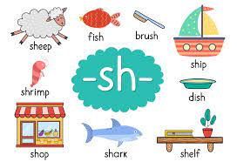 | Numbers to 20  Click on the link below to practise recognising the number words.  https://www.topmarks.co.uk/learning-to-count/teddy-numbers  Click Words up to 15.  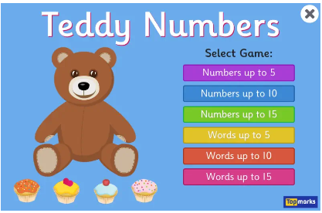
Reading
Your child may bring a reading book home. Please encourage them to point to the words as they read.

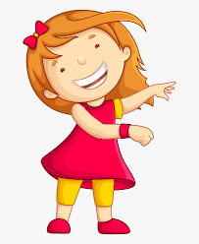Remember to have lots of fun!
Primary 2 Homework
Week Beginning: 4th March 2024
Here is a guide to help you for this week. You can choose how to organise your tasks to suit what works for you.
Please bring book bags to school every day.
*Your child can use their homework jotter for any writing they do.
 | Literacy | Numeracy
 | Split Phoneme  This week’s phoneme is a-e (eg. name).  Click on the link below to find out about the job of ‘Magic e’ for a-e.  https://www.youtube.com/watch?v=HxoTZ_i2rcs  This week’s spelling words are –  cake bake name came game sale brake  Practise writing your spelling words. Diacritically mark the words like you have been doing in your workbooks. This helps to see how the words are made up (eg. joined phonemes, single phonemes, split phonemes).  An explanation of how to do this will be in your child’s book bag.  shake  *Choose some of your words to make sentences with.  The joined phonemes your child should know are –  Group 1 – ay, ea (as in leaf), ow (as in snow)  Group 2 – ue (as in oo and you sounds), aw, oi  Group 3 – au, ew, ow (as in owl), ou  Group 4 – igh, y (as in cry), i-e (as in side), o-e (as in home). | Addition to 20  Click on the link below to practise bridging 10 calculations. Select Level 2.  https://www.sheppardsoftware.com/math/addition/fruit-splat-game/  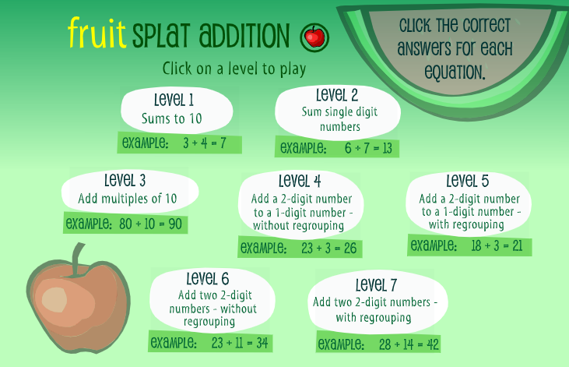
Common Words

This week’s common words are –

take gave cold don’t

Use old newspapers/magazines to cut out the letters to spell your words.

Group 1 words - day away always today each ask year eat yellow grow again food

Group 2 words – blue best number other very took fast there then some their last

Group 3 words – because week keep when what many soon book how where now too round found wish men

Group 4 words – who after hand right fly bring Mr. two five time life line home more school Mrs.
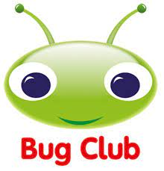
Your child will get their books home in their book bag when they have completed them in class.
Remember to have lots of fun!

