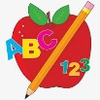Primary 1 Homework
Week Beginning: 26th February 2024
Here is a guide to help you for this week. You can choose how to organise your tasks to suit what works for you.
Please bring book bags to school every day.
 | Literacy | Numeracy
 | Phonics  Your child should now have all the letters of the alphabet. Encourage them to put the letter lids in alphabetical order and say the letter sounds and names.  You will notice they now have a green letter lid. This is called a digraph or joined phoneme. It is the sound make when two letters come together. Encourage your child to make words with the joined phoneme qu. Eg. quiz, quit, quilt, squid, quid.  New sounds this week – q qu  Your child should now have all the letters of the alphabet. If they have any missing letters let us know and we will replace them.  Group 1 - a t s i n p  Group 2 – m r d e c k  Group 3 – g l f o b u  Group 4 – h w j v y z  Group 5 – x q qu | Pictogram  Click on the link below to play the pictogram game.  https://toytheater.com/fruit-fall/  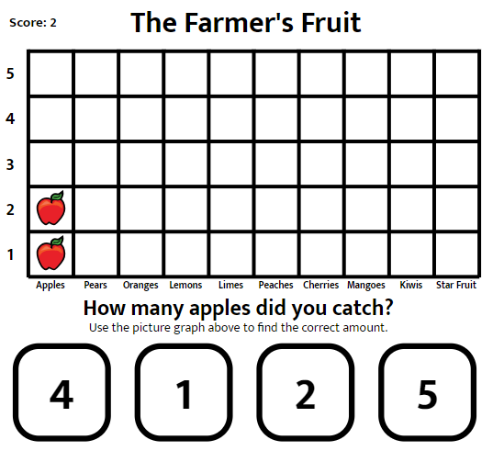
Common Words

We have completed Group 4 words.

This is an assessment week to test the reading and spelling of the words. Continue to practise these at home.

Words the children should now know –
Group 1 – a at the I is it an and in
Group 2 – am as me did he we my can into
Group 3 – go got get if for on be but you
Group 4 – was went his have just to your by only dad are not

Reading
Your child may bring a reading book home. Please encourage them to point to the words as they read.

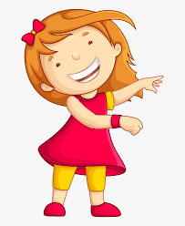Remember to have lots of fun!

Primary 2 Homework
Week Beginning: 26th February 2024
Here is a guide to help you for this week. You can choose how to organise your tasks to suit what works for you.
Here is a guide to help you for this week. You can choose how to organise your tasks to suit what works for you.
Please bring book bags to school every day.
*Your child can use their homework jotter for any writing they do.
 | Literacy | Numeracy
 | Joined Phonemes  This week we are consolidating the joined/split phonemes taught so far.  Continue to get your child to practise identifying the joined/split phonemes and spelling with them.  Look for words using these phonemes in books, magazines, in the environment, etc. Make a note of the ones you find in your jotter. Choose some of the words to make a sentence with. Remember to use capital letters, full stops, finger spaces, and read over it to make sure it makes sense.  The joined phonemes your child should know are –  Group 1 – ay, ea (as in leaf), ow (as in snow)  Group 2 – ue (as in oo and you sounds), aw, oi  Group 3 – au, ew, ow (as in owl), ou  Group 4 – igh, y (as in cry), i-e (as in side), o-e (as in home) | Addition to 20  The children have been exploring missing number calculations. Eg. 8+ =12  7+ =11  +6=13  +3=12  Your child will come home with a number line and calculation sheet/card that they can complete.  Click on the link below to play an addition game. Click on Number Bonds then Addition within 20.  https://www.topmarks.co.uk/maths-games/hit-the-button  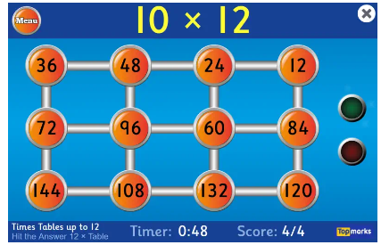
Common Words

This week is for consolidation and assessment. Continue to practise the reading and spelling of all four groups of words. Focus more on the ones that your child may find tricky.

*Group 4 word wall is in your child’s book bag.

Group 1 words - day away always today each ask year eat yellow grow again food

Group 2 words – blue best number other very took fast there then some their last

Group 3 words – because week keep when what many soon book how where now too round found wish men

Group 4 words – who after hand right fly bring Mr. two five time life line home more school Mrs.
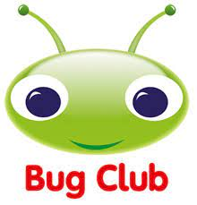
Your child will get their books home in their book bag when they have completed them in class.
Remember to have lots of fun!

