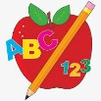
Primary 1 Homework
Primary 2 Homework
Week Beginning: 14th February 2024

No written homework as this is a short week. Your child may get a reading book and they can revise all letter lids and word walls.
*Primary 2 – keep practising all joined/split phonemes.

