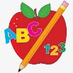 Primary 1 Homework
Week Beginning: 5th February 2024
Here is a guide to help you for this week. You can choose how to organise your tasks to suit what works for you.
Please bring book bags to school every day.
 | Literacy | Numeracy
 | Phonics  Each week your child will get new letters in the form of milk bottle lids. Vowels are red and consonants are blue. They need to know the letter sound, name and write the letter correctly. They should try to make, read and write words with the sounds in their book bag. This is called blending and can be quite tricky to begin with.  New sounds this week – y  The letters that should be in their book bag are –  Group 1 - a t s i n p  Group 2 – m r d e c k  Group 3 – g l f o b u  Group 4 – h w j v y  The focus is to blend the letters to read and write words. Most children should be able to make three letter words but if your child needs a challenge try four/five letter words that can be sounded out. Eg spit, pant, stamp, mint, mist.  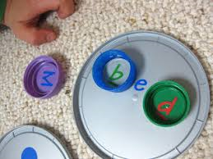  Below is a video below for you to watch to help support your child with blending.  https://watchkin.com/ce7676932f | Time  We have been exploring o’clock times.  Click on the link below and choose Level 1. Remind your child that it is only an o’clock time if the long hand is on the 12.  https://mathsframe.co.uk/en/resources/resource/116/telling-the-time  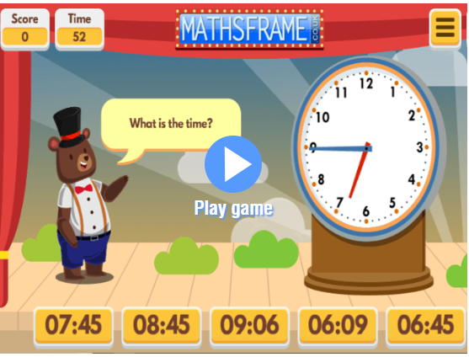
Common Words

We have now moved onto Group 4 words. This week’s words are –
your by only

As we start the new year most children are confident in reading Groups 1 to 3. They are still finding it a bit tricky to spell these words. This week’s homework is to practise spelling the words written in purple.

Words the children should now know –
Group 1 – a at the I is it an and in
Group 2 – am as me did he we my can into
Group 3 – go got get if for on be but you
Group 4 – was went his have just to

*Group 3 word wall is in your child’s book bag.
Reading
Your child may bring a reading book home. Please encourage them to point to the words as they read.

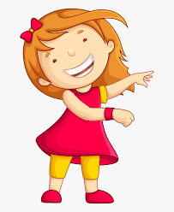Remember to have lots of fun!

Primary 2 Homework
Week Beginning: 5th February 2024
Here is a guide to help you for this week. You can choose how to organise your tasks to suit what works for you.
Here is a guide to help you for this week. You can choose how to organise your tasks to suit what works for you.
Please bring book bags to school every day.
*Your child can use their homework jotter for any writing they do.
 | Literacy | Numeracy
 | Joined Phonemes  This week’s phoneme is i-e (eg. time). This is called a split phoneme.  Click on the link below to find out about the job of ‘Magic e’.  https://www.youtube.com/watch?v=7QXg8bvWXLg  This week’s spelling words are –  side ride hide shine white smile  Practise writing your spelling words. Write or highlight the split phoneme in a different colour, eg side or side.  *Choose some of your words to make sentences with.  The joined phonemes your child should know are –  Group 1 – ay, ea (as in leaf), ow (as in snow)  Group 2 – ue (as in oo and you sounds), aw, oi  Group 3 – au, ew, ow (as in owl), ou  Group 4 – igh, y (as in cry) | Addition to 20  Click on the link below. Your child can use this to work out calculations that bridge 10.  (eg. 9+4, 6+8). This is a strategy where both of the numbers that are being added together are less than ten but add up to a teen number.  https://www.didax.com/apps/ten-frame/  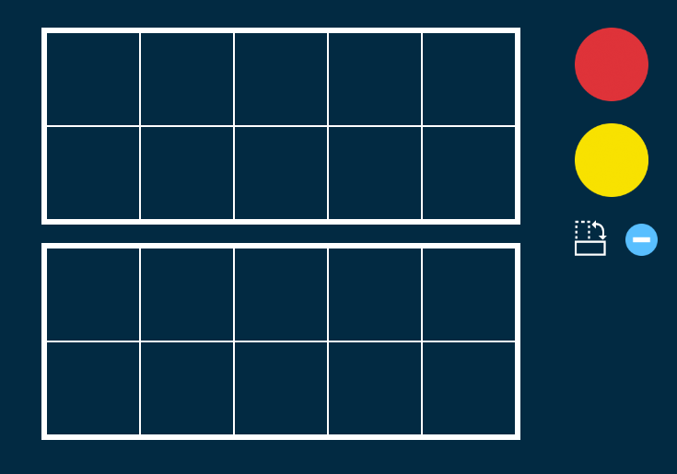  For each number in the addition calculation use a different colour counter – 9+4 (9-red,  4-yellow).  It is easier to make up the first ten frame with the counters and they can see what is left over to add to the 10.  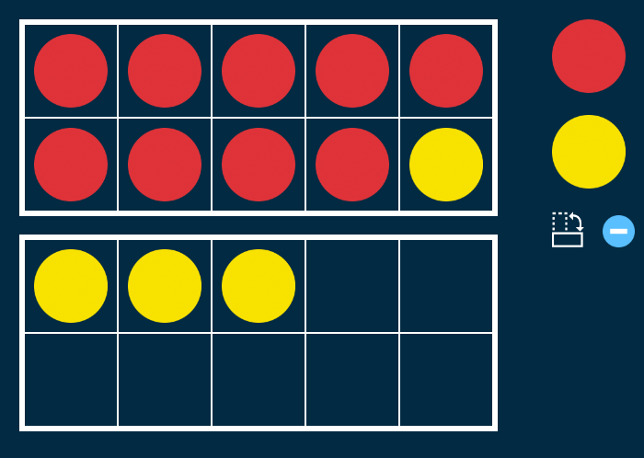  9+4 changes to 10+3 which equals 13  9+4=13  Your child can write the calculations down in their jotter.
Common Words

This week’s common words are –

five time life line

*These words fit in with your spelling focus. Do the spelling activity with these words too.

Practise spelling Group 2 common words

Group 2 words – blue best number other very took fast there then some their last

Try the ‘Look, cover, write and check’ method –
Copy the word, cover it and write it again without looking, then check it. If you did not get it quite right, try it again.

Group 1 words - day away always today each ask year eat yellow grow again food

Group 3 words – because week keep when what many soon book how where now too round found wish men

Group 4 words – who after hand right fly bring Mr. two

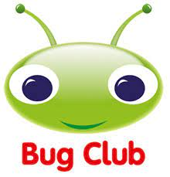
Your child will get their books home in their book bag when they have completed them in class.
Remember to have lots of fun!

