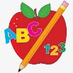 Primary 1 Homework
Week Beginning: 29th January 2024
Here is a guide to help you for this week. You can choose how to organise your tasks to suit what works for you.
Please bring book bags to school every day.
 | Literacy | Numeracy
 | Phonics  Each week your child will get new letters in the form of milk bottle lids. Vowels are red and consonants are blue. They need to know the letter sound, name and write the letter correctly. They should try to make, read and write words with the sounds in their book bag. This is called blending and can be quite tricky to begin with.  New sounds this week – j v  The letters that should be in their book bag are –  Group 1 - a t s i n p  Group 2 – m r d e c k  Group 3 – g l f o b u  Group 4 – h w j v  The focus is to blend the letters to read and write words. Most children should be able to make three letter words but if your child needs a challenge try four/five letter words that can be sounded out. Eg spit, pant, stamp, mint, mist.  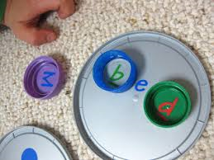  Below is a video below for you to watch to help support your child with blending.  https://watchkin.com/ce7676932f | Numbers to 20  We have been working on numbers to 20. The children should be able to count forwards and backwards and recognise all numbers and number names to 20. Try asking your child to find the number one more than or one less than. Give them two numbers and ask them what one is smaller and what one is larger.  Click on the link below to explore numbers to 20.  https://www.topmarks.co.uk/learning-to-count/todays-number-up-to-20  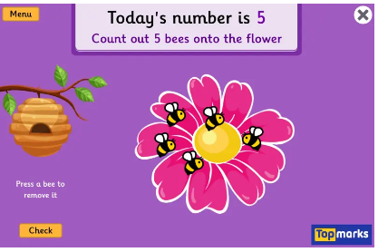
Common Words

We have now moved onto Group 4 words. This week’s words are –
have just to

As we start the new year most children are confident in reading Groups 1 to 3. They are still finding it a bit tricky to spell these words. This week’s homework is to practise spelling the words written in purple.

As we start the new year most children are confident in reading Groups 1 to 3. They are still finding it a bit tricky to spell these words. This week’s homework is to practise spelling the words written in purple.

Words the children should now know –
Group 1 – a at the I is it an and in
Group 2 – am as me did he we my can into
Group 3 – go got get if for on be but you
Group 4 – was went his

*Group 3 word wall is in your child’s book bag.
Reading
Your child may bring a reading book home. Please encourage them to point to the words as they read.

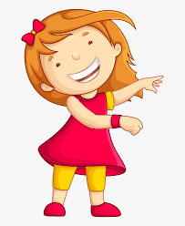Remember to have lots of fun! 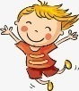

Primary 2 Homework
Week Beginning: 29th January 2024
Here is a guide to help you for this week. You can choose how to organise your tasks to suit what works for you.
Here is a guide to help you for this week. You can choose how to organise your tasks to suit what works for you.
Please bring book bags to school every day.
*Your child can use their homework jotter for any writing they do.
 | Literacy | Numeracy
 | Joined Phonemes  This week practise the two joined phonemes that sound the same - igh and y.  Say different igh/y words to your child, mixing them up. Your child should then write them down. This will help them to practise whether it is igh or y.  For example – sigh, fly, might, flight, myself, light, etc.  The joined phonemes your child should know are –  Group 1 – ay, ea (as in leaf), ow (as in snow)  Group 2 – ue (as in oo and you sounds), aw, oi  Group 3 – au, ew, ow (as in owl), ou  Group 4 – igh, y (as in cry) | Addition to 20  The children are exploring new strategies for addition to 20  – adding 10 to units (eg. 10+4, 8+10)  -adding units to a teen number (eg. 12+2, 15+3, 13+6).  Click on the link below for your child to play a game where they need to use their strategies mentally.  https://www.arcademics.com/games/alien  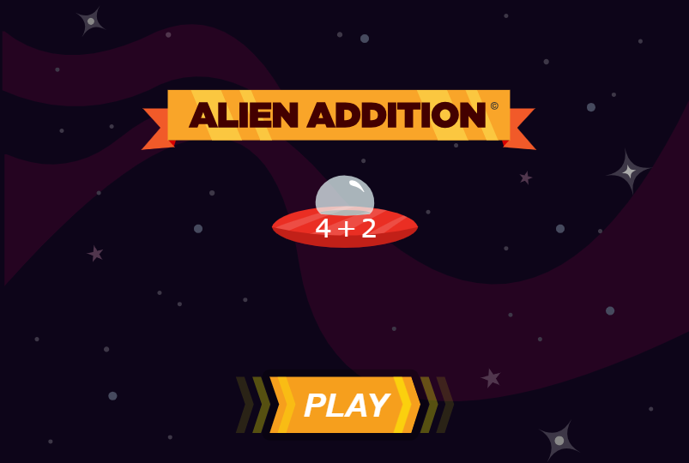
Common Words

This week we are concentrating on the spelling of common words.

Practise spelling Group 1 common words

Group 1 words - day away always today each ask year eat yellow grow again food

Try the ‘Look, cover, write and check’ method –
Copy the word, cover it and write it again without looking, then check it. If you did not get it quite right, try it again.

Group 2 words – blue best number other very took fast there then some their last

Group 3 words – because week keep when what many soon book how where now too round found wish men

Group 4 words – who after hand right fly bring Mr. two

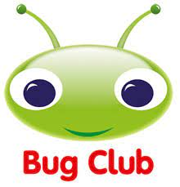
Your child will get their books home in their book bag when they have completed them in class.
Remember to have lots of fun!

