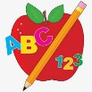 Primary 1 Homework
Week Beginning: 22nd January 2024
Here is a guide to help you for this week. You can choose how to organise your tasks to suit what works for you.
Please bring book bags to school every day. They will be collected in on a Friday as there will not be any homework at the weekend. If you feel you want to continue some of the homework over the weekend, please ask for your child’s book bag.
 | Literacy | Numeracy
 | Phonics  Each week your child will get new letters in the form of milk bottle lids. Vowels are red and consonants are blue. They need to know the letter sound, name and write the letter correctly. They should try to make, read and write words with the sounds in their book bag. This is called blending and can be quite tricky to begin with.  New sounds this week – w  The letters that should be in their book bag are –  Group 1 - a t s i n p  Group 2 – m r d e c k  Group 3 – g l f o b u  Group 4 – h w  The focus is to blend the letters to read and write words. Most children should be able to make three letter words but if your child needs a challenge try four/five letter words that can be sounded out. Eg spit, pant, stamp, mint, mist.  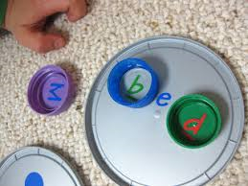  Below is a video below for you to watch to help support your child with blending.  https://watchkin.com/ce7676932f | Time  We are learning about seasons, months and days of the week. This week we will concentrate on days. Below is a song for the children to practise.  https://www.youtube.com/watch?v=3tx0rvuXIRg  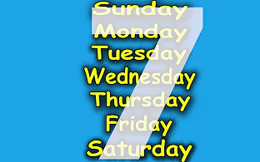  Talk to your child about what day it is. Ask questions like what day comes before, after and in-between. This can be repeated daily to encourage your child to remember the sequence of the days of the week.
Common Words

We have now moved onto Group 4 words. This week’s words are –
was went his

As we start the new year most children are confident in reading Groups 1 to 3. They are still finding it a bit tricky to spell these words. This week’s homework is to practise spelling the words written in purple.

As we start the new year most children are confident in reading Groups 1 to 3. They are still finding it a bit tricky to spell these words. This week’s homework is to practise spelling the words written in purple.

Words the children should now know –
Group 1 – a at the I is it an and in
Group 2 – am as me did he we my can into
Group 3 – go got get if for on be but you

*Group 3 word wall is in your child’s book bag.
Reading
Your child may bring a reading book home. Please encourage them to point to the words as they read.

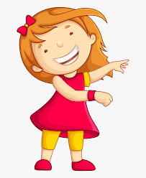Remember to have lots of fun!

Primary 2 Homework
Week Beginning: 22nd January 2024
Here is a guide to help you for this week. You can choose how to organise your tasks to suit what works for you.
Here is a guide to help you for this week. You can choose how to organise your tasks to suit what works for you.
Please bring book bags to school every day. They will be collected in on a Friday as there will not be any homework at the weekend. If you feel you want to continue some of the homework over the weekend, please ask for your child’s book bag.
*Your child can use their homework jotter for any writing they do.
 | Literacy | Numeracy
 | Joined Phonemes  This week we are learning about y (as in ‘sky’).  Get your child to make up the rainbow alphabet. Use the letters with the new joined phoneme to make the words.  fly shy cry sky why dry myself  Write the words in different ways – lowercase letters, uppercase letters, different colours, pens, pencils, paint, chalk outside, etc. They could also be typed onto a computer in different fonts.  The joined phonemes your child should know are –  Group 1 – ay, ea (as in leaf), ow (as in snow)  Group 2 – ue (as in oo and you sounds), aw, oi  Group 3 – au, ew, ow (as in owl), ou  Group 4 - igh | Time  The children are exploring quarter to and quarter past.  https://mathsframe.co.uk/en/resources/resource/116/telling-the-time  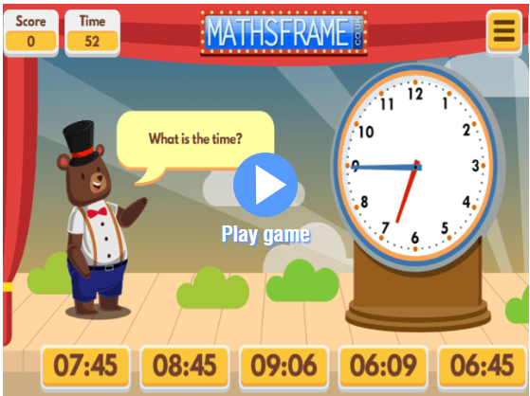
Common Words

The new common words for Group 4 are -
fly bring Mr. two

Try to write each word in a sentence. Remember capital letters, finger spaces and full stops. Could you use any other punctuation in your writing? For example, ? ! …

Group 1 words - day away always today each ask year eat yellow grow again food

Group 2 words – blue best number other very took fast there then some their last

Group 3 words – because week keep when what many soon book how where now too round found wish men

Group 4 words – who after hand right

Keep working on the Word Wall sheets. Continue to practise any words from Group 1, 2 or 3 if they are still proving tricky.

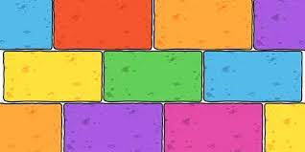
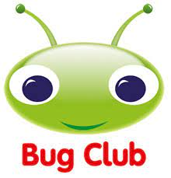
Your child will get their books home in their book bag when they have completed them in class.
Remember to have lots of fun!

