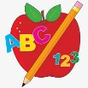 Primary 1 Homework
Week Beginning: 8th January 2024
Here is a guide to help you for this week. You can choose how to organise your tasks to suit what works for you.
Please bring book bags to school every day. They will be collected in on a Friday as there will not be any homework at the weekend. If you feel you want to continue some of the homework over the weekend, please ask for your child’s book bag.
 | Literacy | Numeracy
 | Phonics  Each week your child will get new letters in the form of milk bottle lids. Vowels are red and consonants are blue. They need to know the letter sound, name and write the letter correctly. They should try to make, read and write words with the sounds in their book bag. This is called blending and can be quite tricky to begin with.  New sounds this week – o b  The letters that should be in their book bag are –  Group 1 - a t s i n p  Group 2 – m r d e c k  Group 3 – g l f o b  The focus is to blend the letters to read and write words. Most children should be able to make three letter words but if your child needs a challenge try four/five letter words that can be sounded out. Eg spit, pant, stamp, mint, mist.  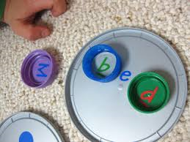  Below is a video below for you to watch to help support your child with blending.  https://watchkin.com/ce7676932f | Numbers to 20  The children will be exploring numbers to 20 in class. They need to know what the number looks like, the number name, number order, what comes before/after/in between and count quantities.  Click on the link below.  https://www.topmarks.co.uk/learning-to-count/todays-number-up-to-20  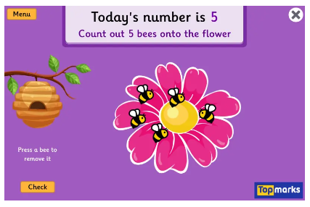
Common Words

Most children can read Group 1 and 2 words. If your child is still finding it difficult to read Group 1 and 2 words use the word walls provided and play splat with a teaspoon.
The expectation is for the children to be able to spell these words independently. Please remember that children progress at different rates. If you feel your child is able to attempt spelling the words they can write them in their jotters.

Group 3 – be but you

Words the children should now know –
Group 1 – a at the I is it an and in
Group 2 – am as me did he we my can into
Group 3 – go got get if for on

*Group 3 word wall is in your child’s book bag.
Reading
Your child may bring a reading book home. Please encourage them to point to the words as they read.

Primary 2 Homework
Week Beginning: 8th January 2024
Here is a guide to help you for this week. You can choose how to organise your tasks to suit what works for you.
Here is a guide to help you for this week. You can choose how to organise your tasks to suit what works for you.
Please bring book bags to school every day. They will be collected in on a Friday as there will not be any homework at the weekend. If you feel you want to continue some of the homework over the weekend, please ask for your child’s book bag.
*Your child can use their homework jotter for any writing they do.
 | Literacy | Numeracy
 | Joined Phonemes  The joined phonemes your child should know are –  Group 1 – ay, ea (as in leaf), ow (as in snow)  Group 2 – ue (as in oo and you sounds), aw, oi  Group 3 – au, ew, ow (as in owl), ou  Write one sentence with a word that uses each of the joined phonemes. Remember your capital letters, finger spaces and full stops.  Click on the link below to play the ‘sentence’ game on Small Town Superheroes.  https://www.bbc.co.uk/games/embed/small-town-superheroes?exitGameUrl=https%3A%2F%2Fbbc.co.uk%2Fbitesize%2Farticles%2Fzncgvk7  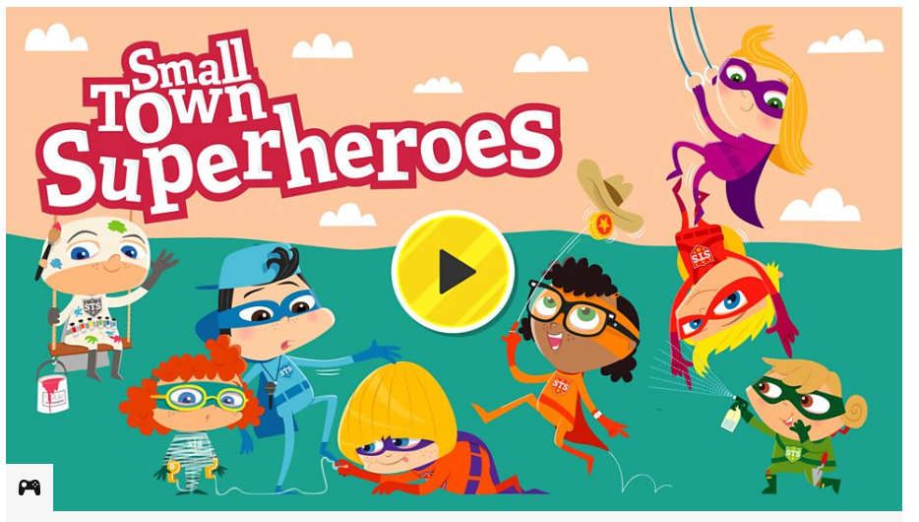  If the link does not work, type into Google – Small Town Superheroes, then click on Sentences. | Time  The children are exploring what quarter to and quarter past means.  Click on the link below and choose Level 3.  https://www.sheppardsoftware.com/math/time/clock-splat-game/  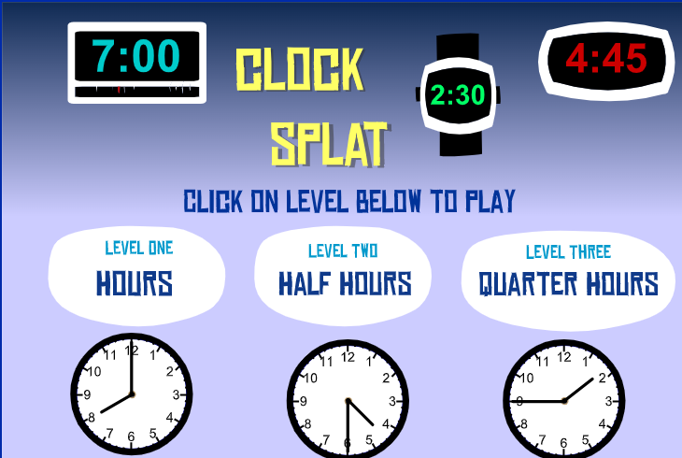
Common Words

Practise spelling/writing the common words taught so far – use the method you prefer (eg. pencils, coloured pencils/pens, crayons, paint, etc.

Group 1 words - day away always today each ask year eat yellow grow again food

Group 2 words – blue best number other very took fast there then some their last

Group 3 words – because week keep when what many soon book how where now too round found wish men

Keep working on the Word Wall sheets. Continue to practise any words from Group 1, 2 or 3 if they are still proving tricky.

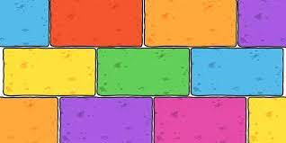
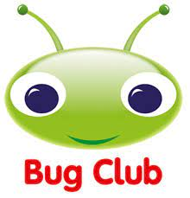
Your child will get their books home in their book bag when they have completed them in class.
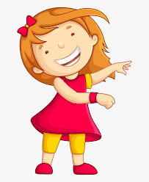Remember to have lots of fun!

