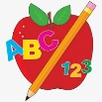 Primary 1 Homework
Week Beginning: 11th December 2023
Here is a guide to help you for this week. You can choose how to organise your tasks to suit what works for you.
This is the last homework before the holidays.
We hope all families have a lovely Christmas!
 | Literacy | Numeracy
 | Phonics  Each week your child will get new letters in the form of milk bottle lids. Vowels are red and consonants are blue. They need to know the letter sound, name and write the letter correctly. They should try to make, read and write words with the sounds in their book bag. This is called blending and can be quite tricky to begin with.  New sound this week - f  The letters that should be in their book bag are –  Group 1 - a t s i n p  Group 2 – m r d e c k  Group 3 – g l f  The focus is to blend the letters to read and write words. Most children should be able to make three letter words but if your child needs a challenge try four/five letter words that can be sounded out. Eg spit, pant, stamp, mint, mist.  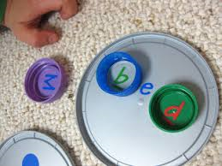  Below is a video below for you to watch to help support your child with blending.  https://watchkin.com/ce7676932f | Seasons  We have been learning about the four seasons. Draw a picture to represent each season.  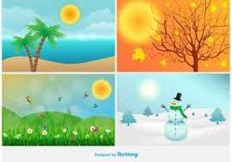
Common Words

Most children can read Group 1 and 2 words. If your child is still finding it difficult to read Group 1 and 2 words use the word walls provided and play splat with a teaspoon.
The expectation is for the children to be able to spell these words independently. Please remember that children progress at different rates. If you feel your child is able to attempt spelling the words they can write them in their jotters.

Group 3 – if for on

Words the children should now know –
Group 1 – a at the I is it an and in
Group 2 – am as me did he we my can into
Group 3 – go got get

Reading
Your child may bring a reading book home. Please encourage them to point to the words as they read.

Primary 2 Homework
Week Beginning: 11th December 2023
Here is a guide to help you for this week. You can choose how to organise your tasks to suit what works for you.
This is the last homework before the holidays.
We hope all families have a lovely Christmas!
 | Literacy | Numeracy
 | Joined Phonemes  This week we are consolidating and assessing all the joined phonemes taught so far (for identifying and blending to read and write words).  The joined phonemes your child should know are –  Group 1 – ay, ea (as in leaf), ow (as in snow)  Group 2 – ue (as in oo and you sounds), aw, oi  Group 3 – au, ew, ow (as in owl), ou | Time  Months of the year – discuss what comes before, after and in between. Can you match the months to the seasons?
Common Words

This week we are consolidating and assessing all the common words taught so far (reading and spelling).

Group 1 words - day away always today each ask year eat yellow grow again food

Group 2 words – blue best number other very took fast there then some their last

Group 3 words – because week keep when what many soon book how where now too round found wish men

*Your child now has the amended Group 3 word wall sheet in their book bags. When your child is able to read and spell a word they can colour in that brick. This is an ongoing activity. Keep working on Group 1 and 2 if you need to.

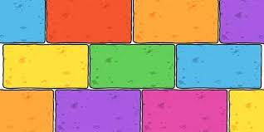
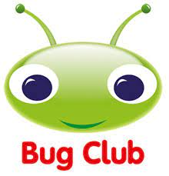
Your child will get their books home in their book bag when they have completed them in class.
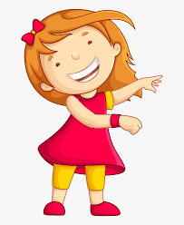Remember to have lots of fun!

