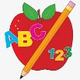 Primary 1 Homework
Week Beginning: 27th November 2023
Here is a guide to help you for this week. You can choose how to organise your tasks to suit what works for you.
Please bring book bags to school every day. They will be collected in on a Friday as there will not be any homework at the weekend. If you feel you want to continue some of the homework over the weekend, please ask for your child’s book bag.
 | Literacy | Numeracy
 | Phonics  Each week your child will get new letters in the form of milk bottle lids. Vowels are red and consonants are blue. They need to know the letter sound, name and write the letter correctly. They should try to make, read and write words with the sounds in their book bag. This is called blending and can be quite tricky to begin with.  New sound this week – g  The letters that should be in their book bag are –  Group 1 - a t s i n p  Group 2 – m r d e c k  Group 3 - g  The focus is to blend the letters to read and write words. Most children should be able to make three letter words but if your child needs a challenge try four/five letter words that can be sounded out. Eg spit, pant, stamp, mint, mist.  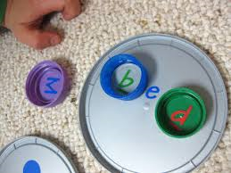  Below is a video below for you to watch to help support your child with blending.  https://watchkin.com/ce7676932f | 3D Shape  We have been exploring 3D shapes – cube, cuboid, cylinder, sphere and cone.  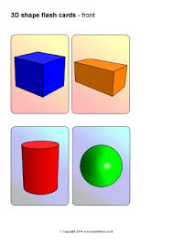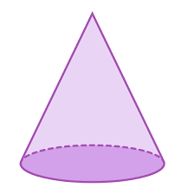  Please discuss the above shapes with your child – how many edges or faces they have, what 2D shapes you can see in them, if they can roll and in what direction etc.  Look for these shapes around the house or out and about and note down what object represents that 3D shape.
Common Words

Most children can read Group 1 and 2 words. If your child is still finding it difficult to read Group 1 and 2 words use the word walls provided and play splat with a teaspoon.
There have been no new words issued this week. The expectation is for the children to be able to spell these words independently. Please remember that children progress at different rates. If you feel your child is able to attempt spelling the words they can write them in their jotters.

Words the children should now know –
Group 1 – a at the I is it an and in
Group 2 – am as me did he we my can into

Reading
Your child may bring a reading book home. Please encourage them to point to the words as they read.

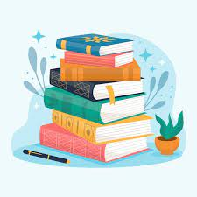

Primary 2 Homework
Week Beginning: 27th November 2023
Here is a guide to help you for this week. You can choose how to organise your tasks to suit what works for you.
Please bring book bags to school every day. They will be collected in on a Friday as there will not be any homework at the weekend. If you feel you want to continue some of the homework over the weekend, please ask for your child’s book bag.
*Your child can use their homework jotter for any writing they do.
 | Literacy | Numeracy
 | Joined Phonemes  This week we are learning about ow (as in owl).  Get your child to make up the rainbow alphabet. Use the letters with the new joined phonemes to make the words.  owl brown growl now crown allow cow  Draw a funny picture using as many spelling words as you can. Label your picture.  The joined phonemes your child should know are –  Group 1 – ay, ea (as in leaf), ow (as in snow)  Group 2 – ue (as in oo and you sounds), aw, oi  Group 3 – au, ew | Numbers to 100  Click on the link below to order numbers to 100  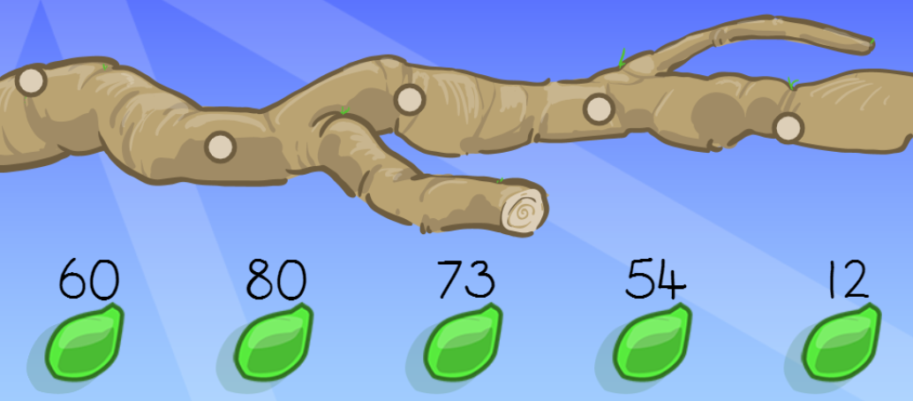  https://ictgames.com/mobilePage/countingCaterpillar/index.html
Common Words

The new common words for Group 3 are -
how where now too

Write your words three times using three different methods, eg. pencil, coloured pencil, black pen, coloured pen, crayon, etc.

Group 1 words - day away always today each ask year eat yellow grow again food

Group 2 words – blue best number other very took fast there then some their last

Group 3 words – because week keep when what many soon book

*Your child has word wall sheets in their book bags with all the words on them for Group 1 and Group 2. When your child is able to read and spell a word they can colour in that brick. This is an ongoing activity.

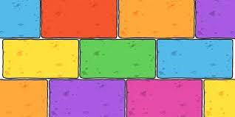
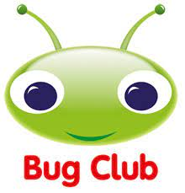
Your child will get their books home in their book bag when they have completed them in class.
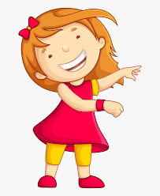Remember to have lots of fun! 