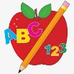 Primary 1 Homework
Week Beginning: 20th November 2023
Here is a guide to help you for this week. You can choose how to organise your tasks to suit what works for you.
Please bring book bags to school every day. They will be collected in on a Friday as there will not be any homework at the weekend. If you feel you want to continue some of the homework over the weekend, please ask for your child’s book bag.
 | Literacy | Numeracy
 | Phonics  Each week your child will get new letters in the form of milk bottle lids. Vowels are red and consonants are blue. They need to know the letter sound, name and write the letter correctly. They should try to make, read and write words with the sounds in their book bag. This is called blending and can be quite tricky to begin with.  New sound this week – c k  The letters that should be in their book bag are –  Group 1 - a t s i n p  Group 2 – m r d e c k  The focus is to blend the letters to read and write words. Most children should be able to make three letter words but if your child needs a challenge try four/five letter words that can be sounded out. Eg spit, pant, stamp, mint, mist.  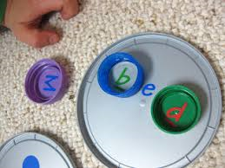  Below is a video below for you to watch to help support your child with blending.  https://watchkin.com/ce7676932f | 2D Shape  Click on the link below to play the Shape Monster game.  https://www.topmarks.co.uk/early-years/shape-monsters  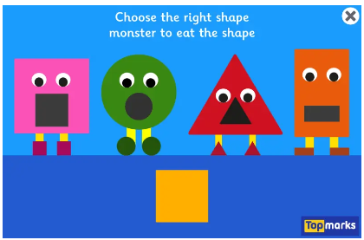
Common Words

Each week your child will be given words to read and spell.
There are activities to help your child to read and spell their common words in their book bag. If you find that Task 4 causes confusion about using capital letters correctly please swap this for Rainbow Writing (writing each letter with a different colour). This list is not prescriptive and the aim is for your child to read and spell their words accurately. If you can find more fun ideas please share with us. Perhaps some outdoor learning using sticks and stones to make the words.

Any evidence can be put in their Homework jotter eg. Photos, pictures, writing and comments.

This week’s words –
my can into

Words the children should now know –
Group 1 – a at the I is it an and in
Group 2 – am as me did he we

Traffic Light words
The green words are for go – your children should know these words. The orange words are for get ready – your children are practising these.
If you find your child is finding some of the words tricky then tell them to keep practising.

*Your child has a word wall in their book bags with Group 1 common words written on it. Please use this to help your child to read and spell these words.

There is also a word wall for Group 2 words in your child’s book bag. If your child is still struggling with Group 1 words keep working on them and move to Group 2 when you think they have a good grasp of Group 1. Please remember that all children progress at different rates.

Reading
Your child may bring a reading book home. Please encourage them to point to the words as they read.

Primary 2 Homework
Week Beginning: 20th November 2023
Here is a guide to help you for this week. You can choose how to organise your tasks to suit what works for you.
Please bring book bags to school every day. They will be collected in on a Friday as there will not be any homework at the weekend. If you feel you want to continue some of the homework over the weekend, please ask for your child’s book bag.
*Your child can use their homework jotter for any writing they do.
 | Literacy | Numeracy
 | Joined Phonemes  This week we are learning about ew.  Get your child to make up the rainbow alphabet. Use the letters with the new joined phonemes to make the words.  drew few flew chew grew blew threw  Practise writing your spellings words. Write the words with a normal writing pencil but write the new joined phoneme in a different colour to highlight it, eg. drew.  Your child could pick at least two words to write a sentence with.  The joined phonemes your child should know are –  Group 1 – ay, ea (as in leaf), ow (as in snow)  Group 2 – ue (as in oo and you sounds), aw, oi  Group 3 - au | Time  We have been exploring half past times.  Click on the link below to play Clock Splat! Choose Level 2 Half Hours.  https://www.sheppardsoftware.com/math/time/clock-splat-game/  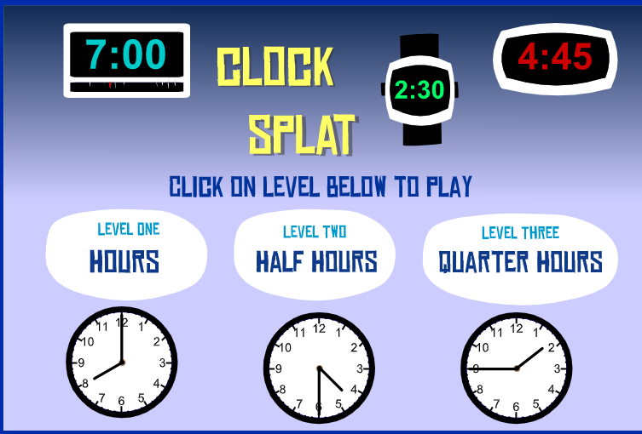
Common Words

The new common words for Group 3 are -
what many soon book

Try writing or typing your words in different styles. Eg. many many many many

Group 1 words - day away always today each ask year eat yellow grow again food

Group 2 words – blue best number other very took fast there then some their last

Group 3 words – because week keep when

*Your child has word wall sheets in their book bags with all the words on them for Group 1 and Group 2. When your child is able to read and spell a word they can colour in that brick. This is an ongoing activity.

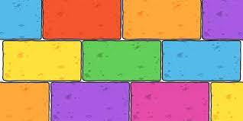
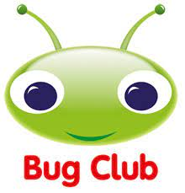
Your child will get their books home in their book bag when they have completed them in class.
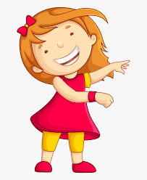Remember to have lots of fun! 