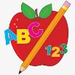 Primary 1 Homework
Week Beginning: 26th September 2023
Here is a guide to help you for this week. You can choose how to organise your tasks to suit what works for you.
Please bring book bags to school every day. They will be collected in on a Friday as there will not be any homework at the weekend. If you feel you want to continue some of the homework over the weekend, please ask for your child’s book bag.
 | Literacy | Numeracy
 | Phonics  Each week your child will get new letters in the form of milk bottle lids. Vowels are red and consonants are blue. They need to know the letter sound, name and write the letter correctly. They should try to make, read and write words with the sounds in their book bag. This is called blending and can be quite tricky to begin with.  The letters that should be in their book bag are –  a t s i  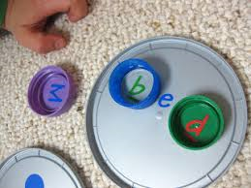  Below is a video below for you to watch to help support your child with blending.  https://watchkin.com/ce7676932f | Writing numbers 0 to 9.  We have attached some number rhymes your child has been learning in class to help them to remember how to write their numbers.  They can write them in chalk, sand, paint, soil, pens, etc.  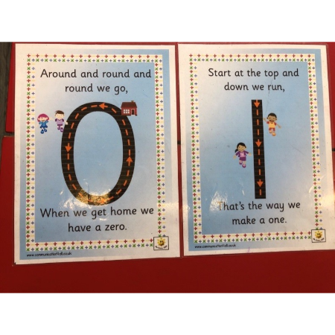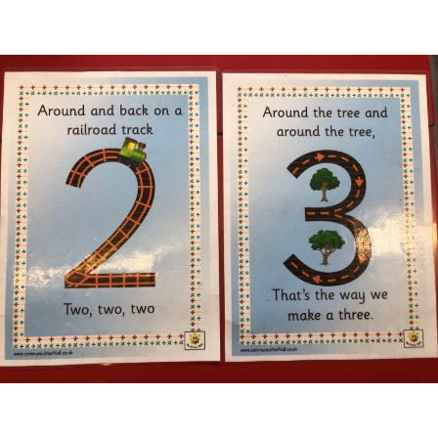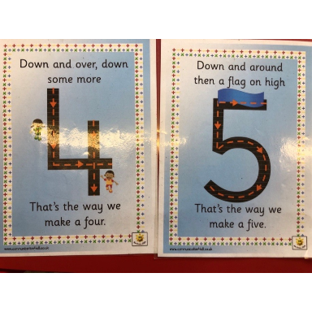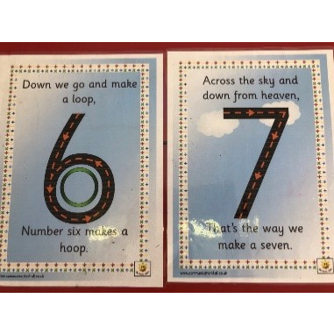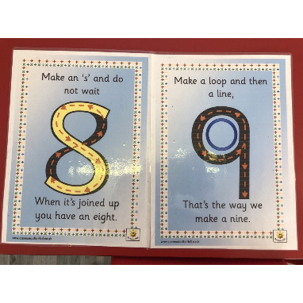
If your child is drawing/colouring, please encourage them to hold their pencil correctly.

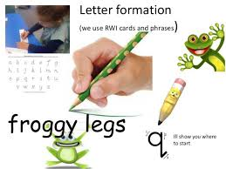
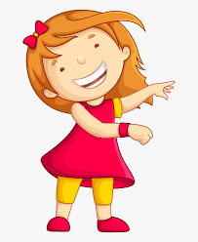Remember to have lots of fun!

Primary 2 Homework
Week Beginning: 26th September 2023
Here is a guide to help you for this week. You can choose how to organise your tasks to suit what works for you.
Please bring book bags to school every day. They will be collected in on a Friday as there will not be any homework at the weekend. If you feel you want to continue some of the homework over the weekend, please ask for your child’s book bag.
*Your child can use their homework jotter for any writing they do.
 | Literacy | Numeracy
 | Joined Phonemes  Your child is learning new P2 joined phonemes. This week we are learning about ow.  Get your child to make up the rainbow alphabet. Use the letters with the new joined phonemes to make the words.  low grow throw follow shallow show  Write each of your spelling words three times. Use a pencil first, then a coloured pencil and lastly in pen.  *If your child wants a challenge they can write a sentence with the words. This is not required but available to do if they wish. | Numbers to 100  The children are exploring numbers to 100.  Click on the link below to play Chopper Squad where your child can practise one more/less and ten more/less.  https://www.topmarks.co.uk/learning-to-count/chopper-squad  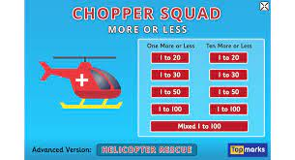
Common Words
The new common words for this week are
yellow grow again food
Look for your common words in books, magazines, posters, etc. Note down how many times you see them.
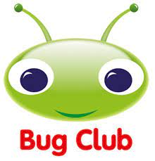
Your child will get their books home in their book bag when they have completed them in class.
Remember to have lots of fun!

