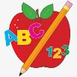 Primary 1 Homework
Week Beginning: 18th September 2023
Here is a guide to help you for this week. You can choose how to organise your tasks to suit what works for you.
Please bring book bags to school every day. They will be collected in on a Friday as there will not be any homework at the weekend. If you feel you want to continue some of the homework over the weekend, please ask for your child’s book bag.
 | Literacy | Numeracy
 | Phonics  Each week your child will get new letters in the form of milk bottle lids. Vowels are red and consonants are blue. They need to know the letter sound, name and write the letter correctly. They should try to make, read and write words with the sounds in their book bag. This is called blending and can be quite tricky to begin with.  The letters that should be in their book bag are –  a t s  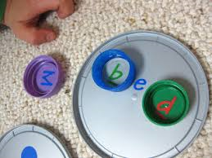  Below is a video below for you to watch to help support your child with blending.  https://watchkin.com/ce7676932f | Your child will have number cards in their book bag. Ask your child to put the cards in order from 0 – 10 and 10 – 0. Ask questions like what comes before, after and in-between a certain number/numbers.  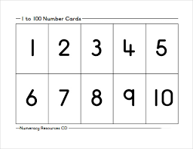
If your child is drawing/colouring, please encourage them to hold their pencil correctly.

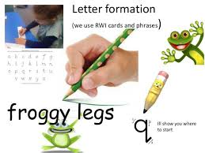
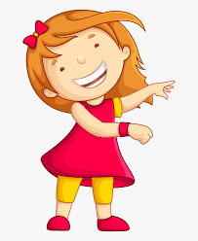Remember to have lots of fun!

Primary 2 Homework
Week Beginning: 18th September 2023
Here is a guide to help you for this week. You can choose how to organise your tasks to suit what works for you.
Please bring book bags to school every day. They will be collected in on a Friday as there will not be any homework at the weekend. If your feel you want to continue some of the homework over the weekend please ask for your child’s book bag.
*Your child can use their homework jotter for any writing they do.
 | Literacy | Numeracy
 | Joined Phonemes  Your child is learning new P2 joined phonemes. This week we are learning about ea.  Get your child to make up the rainbow alphabet. Use the letters with the new joined phonemes to make the words.  speak clean steal team stream eat wheat  Choose a colour for your new joined phoneme and practise writing your spelling and common words (below). For example if you are writing team, pick a colour for the ea and write the rest of your word with a normal writing pencil – team.  *If your child wants a challenge they can write a sentence with the words. This is not required but available to do if they wish. | Numbers to 100  The children are beginning to explore numbers to 100.  Your child will have their 100 square in their book bags. Ask your child to point to different numbers. Ask your child to find the number/numbers before, after and in-between.  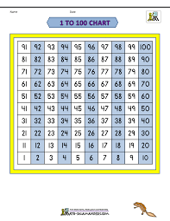
Common Words
The new common words for this week are
each ask year eat

*Most of these words fit in with your spelling activity as they use the new joined phoneme.

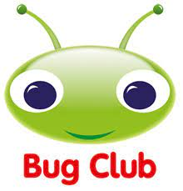

Your child will get their books home in their book bag when they have completed them in class.
Remember to have lots of fun!

