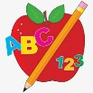 Primary 1 Homework
Week Beginning: 11th September 2023
Here is a guide to help you for this week. You can choose how to organise your tasks to suit what works for you.
Please bring book bags to school every day. They will be collected in on a Friday as there will not be any homework at the weekend. If you feel you want to continue some of the homework over the weekend, please ask for your child’s book bag.
 | Literacy | Numeracy
 | We have been working on syllables in class. Syllables are parts of a word.  Clap out the names of your family in syllables: eg.  Lin-da  2 syllables  Chris-to-pher  3 syllables  James  1 syllable | Your child will have number cards in their book bag. Play the game Splat. Place the cards randomly on the floor. Call out a number and your child should splat it with a spoon. If your child is finding recognising all the numbers tricky, reduce the number of cards. If your child finds recognising the numbers easy, challenge them by clapping your hands and getting them to splat the number.  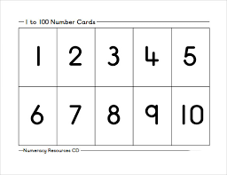
If your child is drawing/colouring, please encourage them to hold their pencil correctly.

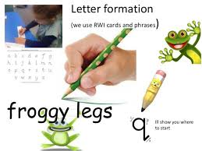
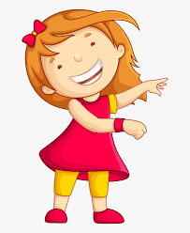Remember to have lots of fun!
Primary 2 Homework
Week Beginning: 11th September 2023
Here is a guide to help you for this week. You can choose how to organise your tasks to suit what works for you.
Please bring book bags to school every day. They will be collected in on a Friday as there will not be any homework at the weekend. If your feel you want to continue some of the homework over the weekend please ask for your child’s book bag.
*Your child can use their homework jotter for any writing they do.
 | Literacy | Numeracy
 | Joined Phonemes  Your child is learning new P2 joined phonemes. This week we are learning about ay.  Get your child to make up the rainbow alphabet. Use the letters with the new joined phonemes to make the words.  day tray play stay prayer way clay  They can write the words in their jotter. Can they think of anymore?  *If your child wants a challenge they can write a sentence with the words. This is not required but available to do if they wish. | Numbers to 100  The children are beginning to explore numbers to 100.  Click on the link below to play the Helicopter Rescue game for numbers to 100.  https://www.topmarks.co.uk/learning-to-count/helicopter-rescue  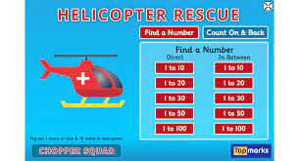
Common Words
The new common words for this week are
day away always today

*These words fit in with your spelling activity as they use the new joined phoneme.
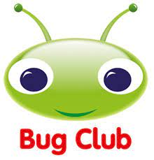

Your child will get their books home in their book bag when they have completed them in class.
Remember to have lots of fun!

