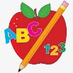 Primary 1 Homework
Week Beginning: 4th September 2023
Here is a guide to help you for this week. You can choose how to organise your tasks to suit what works for you.
Please bring book bags to school every day. They will be collected in on a Friday as there will not be any homework at the weekend. If your feel you want to continue some of the homework over the weekend please ask for your child’s book bag.
 | Literacy | Numeracy
 | Rhyme  We have been working on rhyming words in class. Rhyming words sound the same at the end.  Discuss rhyming words and draw pictures of two rhyming words or find pictures on the computer/magazines and cut out.  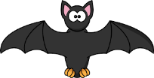  *Your child can use their homework jotter for any drawings or writing they do. | Count forwards and backwards to 10.  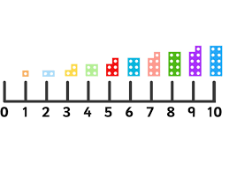  If you feel your child is confident at this encourage them to trying counting forwards and backwards to 20.
 | If your child is drawing/colouring, please encourage them to hold their pencil correctly.  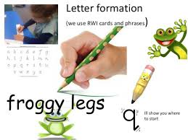 | Identify numbers in your environment when walking to and from school.

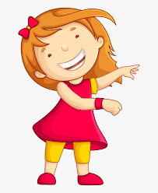Remember to have lots of fun! 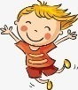
Primary 2 Homework
Week Beginning: 4th September 2023
Here is a guide to help you for this week. You can choose how to organise your tasks to suit what works for you.
Please bring book bags to school every day. They will be collected in on a Friday as there will not be any homework at the weekend. If your feel you want to continue some of the homework over the weekend please ask for your child’s book bag.
*Your child can use their homework jotter for any writing they do.
 | Literacy | Numeracy
 | Revision of joined phonemes  sh th ck qu ch ng wh ph ee oo ai oy oa  Topmarks – Forest Phonics  https://ictgames.com/mobilePage/forestPhonics/index.html | Addition to 10  Subtraction within 10  Click on the link below to play the Robots game.  https://www.topmarks.co.uk/maths-games/robot-more-or-less  Your child can use the number line provided in the game or use their addition/subtraction strategies.  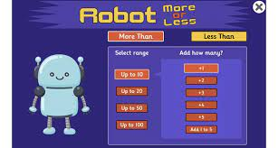
Revision of Common Words

The Common Word walls will be in your child’s book bag so that they can continue to practise reading and spelling/writing the words, especially the ones they find trickier.
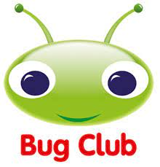

Your child will get their books home in their book bag when they have completed them in class.
Remember to have lots of fun!

