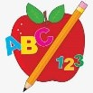 Primary 1 Homework
Week Beginning: 14th June 2026

This is the last homework for P.1. All sounds and words have now been covered as noted below.

 | Literacy | Numeracy
 | Phonics  New Digraph  oa  Write words and draw pictures with the ee digraph. If you want a challenge, write some sentences with the words.  Digraphs covered  qu sh th ch ng wh ph ee oo ck ai oy  All initial sounds covered.  Common Words  Each week your child will be given common words to read and spell.  There are ideas to help your child to read and spell their common words in their book bag. Orange words are new words for this week’s learning. Green words are those your child should know. Some children may need to keep practising the green words for consolidation.  Any evidence can be put in their Homework jotter eg. Photos, pictures, writing and comments.  New Words  all came before could  Group 1  I a at the is it an at and  Group 2  am did me as he into my we can  Keep scrolling down  Group 3  go got get if for on be but you  Group 4  was went his to have just only by your  not dad are  Group 5  she come from this that then so with us of much or  Group 6  old do going out now new first one little  Group 7  had see has play no look said here could  Group 8  our down her make made  This is now groups 1- 6 words completed in class. Children will have word walls in their bookbag. Please keep these safe and revisit often to check reading and spelling.  Reading Book  Children will have reading books in their book bag which they can read to family and friends. Please check book bags each night as they can only keep them for a couple of nights.    Most children have started to explore Hairy Reading on Nessy at home. I hope you are enjoying it and finding it worthwhile  Remember we now have a book swap in class. | Log on to Nessy Numbers.
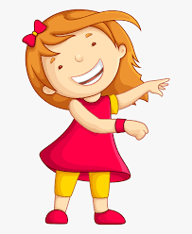Remember to have lots of fun! 