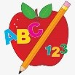 Primary 1 Homework
Week Beginning: 18th May 2026

Please bring book bags to school every day. They will be collected in on a Friday as there will not be any homework at the weekend. If you feel you want to continue some of the homework over the weekend, please ask for your child’s book bag.

 | Literacy | Numeracy
 | Phonics  New Digraph  oo  Write words and draw pictures with the ee digraph. If you want a challenge, write some sentences with the words.  Digraphs covered  qu sh th ch ng wh ph ee  Common Words  Each week your child will be given common words to read and spell.  There are ideas to help your child to read and spell their common words in their book bag. Orange words are new words for this week’s learning. Green words are those your child should know. Some children may need to keep practising the green words for consolidation.  Any evidence can be put in their Homework jotter eg. Photos, pictures, writing and comments.  New words  play no look  Group 1  I a at the is it an at and  Group 2  am did me as he into my we can  Keep scrolling down  Group 3  go got get if for on be but you  Group 4  was went his to have just only by your  not dad are  Group 5  she come from this that then so with us of much or  Group 6  old do going out now new first one little  Group 6  had see has  This is now groups 1- 6 words completed in class. Children will have word walls in their bookbag. Please keep these safe and revisit often to check reading and spelling.  Reading Book  Children will have reading books in their book bag which they can read to family and friends. Please check book bags each night as they can only keep them for a couple of nights.    Most children have started to explore Hairy Reading on Nessy at home. I hope you are enjoying it and finding it worthwhile  Remember we now have a book swap in class. | Scan the QR code to play the toy shop game.  QR CODE  Scan this on mobiles and tablets to quickly open this web page.  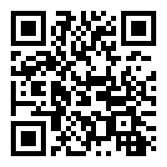
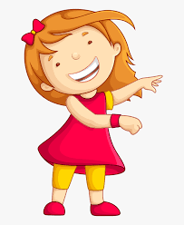Remember to have lots of fun! 