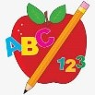 Primary 1 Homework
Week Beginning: 20th April 2026

Please bring book bags to school every day. They will be collected in on a Friday as there will not be any homework at the weekend. If you feel you want to continue some of the homework over the weekend, please ask for your child’s book bag.

 | Literacy | Numeracy
 | Phonics  New Digraph  Ph as in photo  Write as many words as you can with the ph  digraph. Challenge – write some sentences with the words.  Digraphs covered  qu sh th ch ng wh  Common Words  Each week your child will be given common words to read and spell.  There are ideas to help your child to read and spell their common words in their book bag. Orange words are new words for this week’s learning. Green words are those your child should know. Some children may need to keep practising the green words for consolidation.  Any evidence can be put in their Homework jotter eg. Photos, pictures, writing and comments.  Group 6 word wall in bags  New words  first one little  Group 1  I a at the is it an at and  Group 2  am did me as he into my we can  Keep scrolling down  Group 3  go got get if for on be but you  Group 4  was went his to have just only by your  not dad are  Group 5  she come from this that then so with us of much or  Group 6  old do going out now new  This is now group 1- 6 words completed in class. Children will have word walls in their bookbag. Please keep these safe and revisit often to check reading and spelling.  Reading Book  Children will have reading books in their book bag which they can read to family and friends. Please check book bags each night as they can only keep them for a couple of nights.    Most children have started to explore Hairy Reading on Nessy at home. I hope you are enjoying it and finding it worthwhile  Remember we now have a book swap in class. | Most children have started to explore Number Sense on Nessy at home. I hope you are enjoying it and finding it worthwhile.  Try the game below to consolidate subtraction to 10.  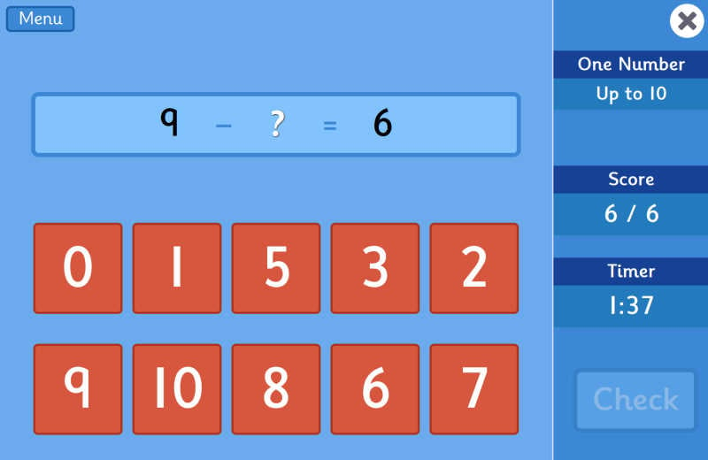  QR CODE  Scan this on mobiles and tablets to quickly open this web page.  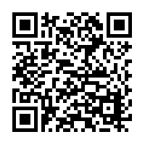
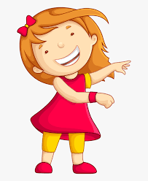Remember to have lots of fun! 